ASCEND Learning Block Training Strategy
Need support establishing a consolidated Philippines view across Nuvali, Iloilo, and Clark, specifically identifying the 20-person classes where secondary Trainers are being removed and Coach support will be required. This will enable us to align Coach coverage to immediate class needs while creating capacity for Ascend upskilling.

Contents
Learning Block 1: Welcome to Asurion 3
Learning Block 2: Expert Foundations- The Tech Coach Role & Call Flow 4
Learning Block 3: Tools for the Call Flow- Asurion Tools 7
Learning Block 4: Tools for the Call Flow- Client Tools 9
Learning Block 5: Sales Foundation- Product Knowledge, Compliance, & Integrity 11
Learning Block 6: Call Flow Stage 1: Greeting, Verify, Asses, Empathy & Assurance 13
Learning Block 7: Call Flow Stage 2: Troubleshooting Basics 16
Learning Block 8: Call Flow Stage 3: Solve & Test - Device Basics 18
Learning Block 9: Call Flow Stage 3- Solve & Test- Hardware vs Software 20
Learning Block 10: Call Flow Stage 3- Solve & Test- Networking 22
Learning Block 11: Call Flow Stage 3- Solve & Test- Activations and Device Onboarding 25
Learning Block 12: Call Flow Stage 3- Solve & Test- Carrier Account 28
Learning Block 13: Call Flow Stage 3- Solve & Test- Insurance & Warranty Claims 30
Learning Block 14: Call Flow Stage 4- Sales in Action 32
Learning Block 15: Call Flow Stage 5- Confirm, Recap, Close Part 2 35
Learning Block 16: Expert Readiness- Training Closing 37
Additional Activities 40
LaunchPad Outcome 40

ASCEND™ is our enterprise strategy for transforming how we develop experts across the organization. The Launchpad training strategy was designed to prepare Experts for their job by shifting the learning experience from content completion to demonstrated readiness. Experts will learn through bite-size CBTs that introduce essential knowledge and happy-path workflows, then immediately apply those skills through guided practice, Training Assist scenarios, simulations, coaching, and remediation. This structure helps Experts build confidence and consistency by practicing the work before they are expected to perform it with customers.
Throughout training, Experts will complete 100+ progressive, trackable simulated customer interactions aligned to business demand, customer impact, and known performance gaps. These simulations will focus on high-priority call types that cover 80%+ of scenarios, such as activations, network troubleshooting, insurance and warranty support, carrier account needs, apps and software issues, hardware triage, and mixed-intent scenarios. By the end of training, Experts will be expected to demonstrate accurate verification, proper CPNI handling, correct tool and workflow use, strong customer experience behaviors, sound troubleshooting logic, appropriate scope and transfer decisions, compliant sales behaviors, accurate documentation, and readiness to support customers.
  - Supplemental Notes:
- Training Resources
  - Visual Support for Training Development
    - CBT, Trainer Guide, and Simulation Job Aid templates will be created to give all training materials a cohesive look and feel, creating a better training experience for both trainers and learners.
    - Also, visual design will partner with TD to visually design materials needed for trainer upskilling sessions to align to the cohesive experience.
  - Ascend User Manual
    - A high-level overview for trainers and leaders to detail the Ascend training experience at a high level, along with expectations for the duration of the Launchpad phase and resources they can use throughout.
  - Learning Block Trainer Guides
    - Each learning block will include a Trainer Guide that covers the learning objectives and core concepts in the Learning Block, expectations for that section, knowledge checks, and remediation. Plus, recommended sequence, estimated timing, transitions, and break points.
    - It will also include Trainer Expectations while Experts are working through self-paced training and simulations
  - Job Aids for experts to reference with steps and tips they’ll need to complete a simulation.
  - Each simulation should have a unique ID number, so scenarios can be tracked, assigned, updated, and referenced consistently. A breakdown of the simulations can be found here: Ascend Simulations.xlsx
- Classroom Branding, Celebration, and Recognition
  - In order to immerse the new hires in the ASCEND experience and give it a different feel, the team is working on classroom branding that could include custom wall wraps, desktop backgrounds, and laminated posters to improve classroom appearance and create a warm and welcoming learning environment. Also looking at options for a Day 1 welcome gift to have on desks to welcome experts to Asurion and generate excitement.
  - For celebration and recognition, raffle tickets will be awarded to recognize the completion of specific tasks (i.e. 50th simulation completion, 100th simulation completion, scored 100% on troubleshooting knowledge check, etc.) and to positively reinforce behaviors exhibited by successful experts. Raffle winners can win ACE points and other prizes to be determined. There will also be a certificate of completion to celebrate and recognize the accomplishment of completing Launchpad.
Total Number
Learning Blocks | 16
ILT | 1
CBTs | 45
Videos | 23
Simulations | 189

  - Instructional Design Guidance
For every course within this learning block, instructional designers should define:
- Content: What information is delivered.
- Modality: How the learning is delivered (ILT, CBT, simulation, activity, etc.).
- Practice: How Experts apply the knowledge or skill.
- Performance Check: How proficiency is demonstrated.
- Minimum Readiness Criteria: The observable behaviors or outcomes required before progressing to the next learning block.

Learning Block 1: Welcome to Asurion
  - Purpose of the Learning Block
- The Welcome to Asurion learning block establishes the foundation for every Expert's success. It introduces Asurion's culture, values, and expectations while ensuring Experts can confidently navigate the core systems, resources, and policies required throughout training. By the end of this learning block, Experts should understand how their role contributes to the customer experience, know where to find support, and demonstrate safe, compliant handling of customer and company information.
  - Learning Objectives
By the end of this learning block, Experts will be able to:
- Explain Asurion's mission, culture, and role expectations.
- Navigate core employee systems and learning resources (Homebase, Workday, Workday Learning, UKG, Quest Password Manager).
- Apply day-one policies related to attendance, equipment, clean desk practices, information security, and collaboration tools.
- Demonstrate proper handling of customer and company information, including CPNI requirements.
- Locate and use approved resources to resolve common employee, learning, and system-access questions.

  - Key Questions Answered
Upon completion of this learning block, Experts should be able to answer:

Company & Culture
- What is Asurion, and how does the Asurion way influence daily behaviors?
- How does Compassion Forward connect to the Expert role?
- What are ERGs and how can I join?
- How does my role contribute to creating world-class customer experiences?

Training Expectations
- What should I expect throughout training?
- What can I expect from my trainer?
- What does successful completion of this learning block look like?

Systems
- How do I access Homebase, Workday, Workday Learning, UKG, and Quest Password Manager?
- Where do I go when I have a policy, learning, or system-access question?

Policies
- What day-one policies apply to attendance, equipment, clean desk practices, information handling, and Microsoft Teams retention?
- What is CPNI, and how do I protect customer information?

  - Core Capabilities
Upon successful completion of this learning block, Experts are prepared to:
- Operate independently within the Asurion learning environment by accessing required systems, completing assigned learning, and locating approved employee resources without instructor assistance.
- Work within Asurion’s operational and compliance expectations by consistently applying information security, CPNI, equipment, attendance, and workplace policies throughout training.
- Use approved resources as the primary source of truth for workplace questions, learning activities, and system-access issues rather than relying on memory or informal guidance.
- Participate effectively in the Launchpad learning experience by managing assigned learning, meeting participation expectations, communicating barriers, and using available support resources appropriately.
- Demonstrate the professional behaviors and learning habits expected throughout the remainder of Launchpad and in future customer interactions.
  - Assessment Methods
- Knowledge Checks
- Guided Lab Activities
- Observation
- Required Compliance CBTs

  - Minimum Performance Expectations
Experts must demonstrate the ability to:
- Successfully complete 100% of required onboarding, compliance, and acknowledgment activities before progressing to Learning Block 2.
- Independently access Homebase, Workday, Workday Learning, UKG, and Quest Password Manager in 100% of evaluated system-access activities without instructor assistance.
- Locate the correct employee policy, learning resource, or support process in 90% of evaluated workplace scenarios involving attendance, equipment, learning, collaboration tools, or system access.
- Correctly apply CPNI, clean desk, information security, and equipment handling requirements in 100% of evaluated compliance scenarios without committing a compliance violation.
- Use approved company resources rather than memory or informal guidance to resolve workplace questions in 90% of evaluated resource lookup scenarios.
- Correctly identify the appropriate support resource for employee, learning, or system-access issues in 90% of evaluated workplace scenarios.
- Complete 100% of assigned learning activities and demonstrate readiness to progress by meeting participation expectations and communicating barriers that prevent successful completion of required learning.
  - Remediation Required When
- Required systems cannot be accessed.
- Incorrect resources or policies are selected.
- Information security or CPNI requirements are violated.
- Instructor assistance is consistently required to locate basic resources.
  - Courses and Resources (~4.5 hour)
Content | Modality | Length | Core Capabilities # | Simulation | High-Level Description
Welcome to Asurion Video | Video | 5 min |  | N/A | This is a welcome message from Guru
AI Intro Activity  (ASCEND) | ILT | 45 min | 4 | N/A | an AI integrated activity that the trainer will lead them through
QPM Resource | Resource | 15 min |  |  | This will be what the trainers use to get Experts into their systems.
Intro to the Lab | Activity | 30 min | N/A- Intro to lab activity to set the stage for activities during training. Observe what they are familiar with. | N/A | Familiarize Experts with the devices and technology they will support, allowing them to begin connecting classroom learning to real customer experiences through guided exploration.
Welcome to Asurion: The Training Journey | CBT | 20 min | 2, 8 | N/A | This CBT will introduce Experts to their Asurion Journey. It will also include training expectations and the 100+ simulations, their role in their training experience, and the trainer role. It will also include the myJourney video.
The Asurion Way | CBT | 15 minutes |  | N/A | This CBT introduces the Asurion Way
HR Essentials | CBT | 20 min |  | N/A | This CBT will replace the need for an HR visit. Currently waiting for HRs response to replacing their visit with a CBT.
Asurion Essentials | CBT | 15 min | 3, 7 | N/A | Introduce Homebase, Workday, Workday Learning, UKG, and core employee resources.
Compassion Forward and Inclusion & Belonging | CBT | 15 | 7 | N/A | This CBT goes over Compassion Forward and our current ERGs. It includes resources of where to find information on them in Homebase and how to sign up for ERGs.
Jabra Headset Policies | CBT | 5 min (required outside-core) | 6 | N/A | Review headset policy requirements.
Asurion_All_CPNI and Asurion | CBT | 15 min (required outside-core) | 5 | N/A | Introduce customer information handling and CPNI requirements.
Acknowledgement Courses | CBT bundle | 30 min (required outside-core) | 2, 5, 6 | N/A | Complete required acknowledgments, including Treatment of Information, Employee Certification, Clean Desk, Attendance, and Learning Expectations.
Microsoft Teams Retention Policy | CBT | 5 min (required outside-core) | 5 | N/A | Review collaboration and retention requirements.
Integrity First Bundle | CBT bundle | 90 min (required outside-core) | 1 | N/A | Complete required ethics and compliance training.

Learning Block 2: Expert Foundations- The Tech Coach Role & Call Flow
  - Purpose of the Learning Block
The Expert Foundations learning block establishes the core behaviors, decision-making framework, and customer interaction model every Expert must demonstrate before progressing to product- and technology-specific support. By the end of this learning block, Experts should be able to confidently manage a foundational customer interaction by applying the Tech Coach role, following the standard call flow, using the Serve/Solve/Sell methodology, making basic decisions, and communicating clear next steps.

  - Learning Objectives
By the end of this learning block, Experts will be able to:
- Explain the Tech Coach role and how it contributes to creating world-class customer experiences.
- Demonstrate the standard customer call flow from greeting through close.
- Apply the Serve/Solve/Sell model throughout a customer interaction.
- Determine the appropriate support path by distinguishing between in-scope requests, self-service opportunities, transfers, and escalations using approved resources.
- Use approved resources to verify customer-impacting decisions before selecting a workflow, providing guidance, or communicating next steps.
- Use probing questions, active listening, and customer responses to identify the customer’s need before selecting a resolution path.
- Maintain ownership of the interaction by communicating expectations, confirming understanding, and guiding the customer through the approved support process.

  - Key Questions Answered
Upon completion of this learning block, Experts should be able to answer:

The Expert Role
- What is my role as a Tech Coach Expert?
- What customer experience am I responsible for creating?

Customer Conversations
- How do I structure a customer interaction from beginning to end?
- How does the standard call flow guide every conversation?
- How do I naturally Serve, Solve, and Sell during a customer interaction?

Decision Making
- What is my scope of support?
- How do I determine whether a request is in scope or out of scope?
- Where do I verify my decision before taking action?
- How do I handle a customer request that is outside my scope?

Readiness
- What does successful completion of this learning block look like?

  - Core Capabilities
Upon successful completion of this learning block, Experts will be able to:
- Manage structured customer interactions using the Tech Coach operating model from initial customer engagement through transition to the appropriate support path.
- Evaluate customer needs and determine the appropriate support path by distinguishing between in-scope support, self-service opportunities, transfers, and escalations.
- Use approved resources as the primary source of truth when making customer-impacting decisions, selecting workflows, and communicating next steps.
- Guide customer conversations using purposeful discovery, active listening, empathy, and expectation setting to build customer confidence and maintain ownership throughout the interaction.
- Balance customer experience, operational requirements, and business processes while maintaining control of customer interaction.
- Establish the foundational customer interaction behaviors that support all subsequent troubleshooting, activation, account support, claims, and sales conversations throughout Launchpad.

  - Assessment Methods
- Knowledge Checks
- Simulations
  - Training Assist
  - Assima- Expert Workspace

  - Minimum Performance Expectations
Experts must demonstrate the ability to:
- Successfully complete all 13 required Expert Foundations simulations, including successful re-demonstration of any skill requiring coaching before progressing.
- Correctly identify the customer’s reason for contact and applicable call type in 10 of 10 evaluated customer scenarios before selecting a workflow or providing guidance.
- Correctly distinguish between in-scope requests, self-service opportunities, transfers, and escalations in 9 of 10 evaluated scenarios using approved resources and without making unsupported promises.
- Ask at least two relevant clarifying questions in 9 of 10 evaluated customer scenarios before selecting a resolution path.
- Accurately paraphrase the customer’s stated concern and confirm understanding in 9 of 10 evaluated customer interactions before proceeding with troubleshooting or support.
- Respond to customer emotion with a relevant acknowledgment and credible assurance statement in 9 of 10 evaluated customer interactions.
- Use approved resources to verify customer-impacting decisions in 100% of evaluated scenarios before selecting a workflow or communicating next steps.
- Maintain control of the interaction in 9 of 10 evaluated scenarios by acknowledging customer suggestions, redirecting premature troubleshooting, and guiding the customer through the approved call flow.
- Successfully complete the foundational customer interaction in 9 of 10 evaluated simulations by:
  - Delivering the approved greeting.
  - Identifying the customer’s reason for contact.
  - Applying empathy and assurance.
  - Asking probing and discovery questions.
  - Confirming customer intent.
  - Setting appropriate expectations.
  - Providing a clear recap and professional close.
de
  - Courses and Resources (~1 hour)
Course | Modality | Length | Stakeholder Review | Core Capabilities # | Simulations | High-Level Description
Intro to Tech Coach Role | Video | 10 min | 7/30 | 1 | N/A | Introduces the Expert role, day-in-the-life expectations, supported customer needs, tools, and how sales/VHDP may appear.
Serve/Solve/Sell Overview | Video | 5 min | 7/30 | 3 | 1 | Introduces Serve, Solve, and Sell as the core customer-interaction model.
Call Flow Overview | Video | 10 min | Current Course | 2 | 10 | Introduces the high-level structure of a customer interaction from opening through close.
Call Flow: Closer Look | CBT | 20 min | ~8/18 | 2, 3, 5, 7 | 10 | Provide a deeper dive for Experts to understand each part of the call flow and begin practicing how to move through a customer interaction. The CBT should focus on sequencing, decision-making, and language, like how to verify the customer on the account, ask probing questions to understand the customer's issue, the appropriate tools to use, how Serve/Solve/Sell shows up in the call flow, how to close the interaction confidently and more.
Intro to Scope of Support | CBT | 20 min | Current Course | 4, 6, 7 | 2 | Introduces scope decisioning, approved resources, and professional next-step communication. Experts should learn how to determine whether they can support the request, where to verify the answer, and what to do next.

  - Simulation Strategy (~1 hour)
After completing the foundational videos and CBT content, Experts should move into simulation-based practice. Simulations should give Experts the opportunity to apply what they learned in realistic customer scenarios, including how to show up in the Tech Coach role, follow the universal call flow, use Serve Solve Sell behaviors, and make basic scope decisions.
The simulations should build in complexity over time. Experts should begin with simple recognition and decision-making scenarios, such as identifying the customer’s need, choosing the next best probing question, or determining whether a request is in scope or out of scope. They should then progress into more realistic roleplay and branching scenarios that require them to use call flow, set expectations, and clearly recap next steps with the customer.
Simulation practice should assess whether Experts can apply the foundational behaviors together, not just recall them individually. By the end of the simulation sequence, Experts should be able to demonstrate role clarity, customer-centered communication, basic call control, Serve Solve Sell application, scope decision-making, source-of-truth behavior, and confident expectation setting.

Total Simulations for this learning Block- 13
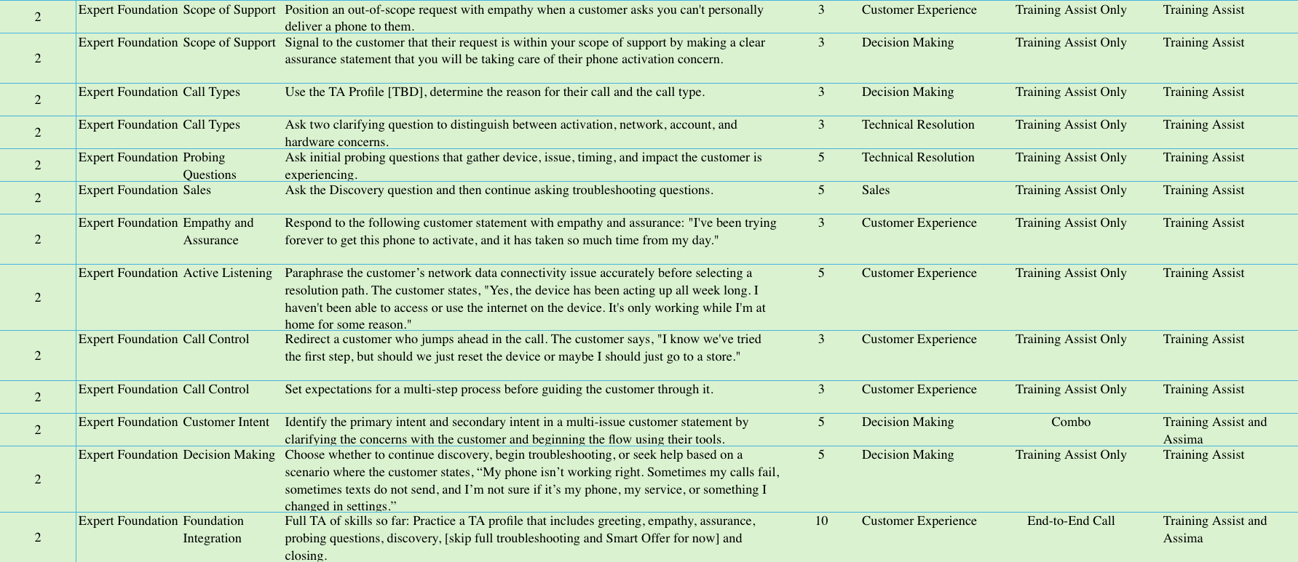

  - Instructional Design Guidance
For every course within this learning block, instructional designers should define:
- Content: What information is delivered.
- Modality: How the learning is delivered (ILT, CBT, simulation, activity, etc.).
- Practice: How Experts apply the knowledge or skill.
- Performance Check: How proficiency is demonstrated.
- Minimum Readiness Criteria: The observable behaviors or outcomes required before progressing to the next learning block.

Learning Block 3: Tools for the Call Flow- Asurion Tools
  - Purpose of this Block
The Asurion Tools learning block introduces Experts to Expert Workspace, Expert Assist, Helix Search, Guided Flows, and LogMeIn. By the end of the block, Experts should be able to explain when each tool is used, select and navigate the appropriate tool for a basic customer need, locate and follow approved guidance, and move to another approved resource when the first path does not fit. Experts will also practice keeping the customer informed and explaining tool-guided steps clearly, creating a foundation for later learning blocks focused on client tools, verification, troubleshooting, activations, account support, and sales.
  - Learning Objectives
By the end of this learning block, Experts will be able to:
- Explain the purpose and appropriate use of Expert Workspace, Expert Assist, Helix Search, Guided Flows, and LogMeIn.
- Ask basic probing questions and select the appropriate Asurion tool or resource based on the customer’s stated need.
- Navigate Expert Workspace and use Expert Assist and Helix Search to locate approved guidance, knowledge resources, and job aids.
- Follow a Guided Flow for a simple customer need and determine when LogMeIn is appropriate based on the device, operating system, and available permissions.
- Maintain ownership of the customer conversation by communicating progress and explaining tool-guided actions in clear, customer-friendly language.
- Determine when an initial search result, prompt, Guided Flow, or remote-support path does not fit the customer’s situation and pivot to another approved resource or client-specific tool rather than guessing.
  - Key Questions Answered
The learning block should help Experts answer the following questions:
Asurion Tool Ecosystem
- What are the primary Asurion tools Experts use during customer interactions?
- What is Expert Workspace used for?
- What is Expert Assist used for?
- What is Helix Search used for?
- What are Guided Flows used for?
- What is LogMeIn used for?
Tool Selection and Decision-Making
- When should Experts use each tool?
- How do Experts determine which tool or resource best supports the customer’s need?
- How do Experts use approved tools and resources instead of guessing?
Customer Communication
- How do Experts keep the customer informed while navigating and using tools?
- How do Experts translate tool guidance into clear, customer-friendly next steps?
Adjusting the Tool Path
- What should Experts do when the first search result, tool prompt, Guided Flow path, or remote-support path does not fit the customer’s situation?
- How do Experts determine when to continue with the current tool, return to an earlier decision point, or select another approved resource?
Tool Boundaries
- Where does Asurion tool support stop before client tools are needed?
- How do Experts recognize when they need to move from an Asurion tool to a client tool or another approved support path?

  - Core Capabilities
Upon successful completion of this learning block, Experts are prepared to:
- Support customer interactions by selecting and using the appropriate Asurion tools to locate approved guidance, complete workflows, and determine the appropriate next action.
- Navigate the Asurion tool ecosystem efficiently while maintaining ownership of the customer conversation and minimizing unnecessary customer effort.
- Use approved tools and resources as the primary source of truth when making customer-impacting decisions, selecting workflows, and communicating guidance.
- Adapt to changing customer needs by recognizing when a tool, workflow, or search result does not support the situation and selecting the appropriate alternative resource or support path.
- Translate tool guidance into clear, customer-friendly communication that keeps customers informed, sets expectations, and explains next steps throughout the interaction.
- Build the foundational tool proficiency required to support client systems, troubleshooting, activations, account support, claims, and sales workflows throughout the remainder of Launchpad.
  - Assessment Methods
- Knowledge Check
- Simulation
  - Training Assist
  - Assima-
    - Expert Workspace- includes Expert Assist and Guided Flows
    - Helix Search

  - Minimum Performance Expectations
Experts must demonstrate the ability to:
- Successfully complete all 10 required Asurion Tools simulations, including successful re-demonstration of any skill requiring coaching before progressing.
- Independently launch Citrix, Expert Workspace, and Helix Search in 100% of evaluated tool scenarios without trainer assistance.
- Select the appropriate Asurion tool before beginning the customer-support workflow in 9 of 10 evaluated customer scenarios.
- Use Expert Workspace to locate and identify the correct customer line and supporting account information in 10 of 10 assigned account-lookup scenarios.
- Create complete Expert Assist prompts that include the customer’s issue, affected device or application, relevant context, and previously attempted troubleshooting in 9 of 10 evaluated scenarios.
- Use Helix Search to locate the current approved resource and identify the supported next action in 9 of 10 evaluated search scenarios.
- Complete Guided Flow activities by selecting the correct workflow, following required steps in sequence, and identifying the supported next action in 3 of the 10 evaluated scenarios.
- Determine when LogMeIn is an appropriate support tool based on the customer’s device, operating system, permissions, and support need in 9 of 10 evaluated customer scenarios.
- Maintain customer ownership during 9 of 10 evaluated tool interactions by explaining what is being checked, why it is being checked, and the expected next step while navigating support tools.
- Complete required documentation in 100% of evaluated documentation scenarios by accurately recording the customer issue, actions taken, outcome, and next step.
- Recover from unsuccessful search results, tool prompts, or workflow paths in 9 of 10 evaluated scenarios by selecting another approved resource rather than relying on memory or unsupported guidance.
- Complete all evaluated tool activities with zero critical customer-information, workflow, or documentation errors.

  - Courses and Resources (~2 hours)
Course | Modality | Length | Stakeholder Review | Core Capabilities # | Simulations | High-Level Description
Expert Workspace Overview | Video | 5 min | Current Course | 1 | 5 | This short orientation video introduces Expert Workspace as the primary environment Experts use during calls. Learners see how strong navigation supports accuracy, productivity, and the customer experience.
Expert Workspace | CBT | 20 min | 8/11 | 1-6 | 5 | This CBT builds beginner Expert Workspace navigation skills. Learners practice recognizing key areas, staying oriented, avoiding over-clicking, and using workspace information to support call accuracy.
Expert Assist Review | Video | 5 min | Current Course | 1 | 3 | This short video creates hype around Expert Assist and how it supports customer interactions. Learners see how to use its guidance alongside active listening, probing, judgment, and other tools.
Helix Search | CBT | 10 min | 8/11 | 1-6 | 1 | This CBT builds Helix Search skills for finding approved information during calls. Learners practice using strong search terms, choosing relevant resources, and knowing when to use another tool.
Guided Flows | CBT | 20 min | 8/11 | 1-6 | 4 | This CBT builds Guided Flow skills for structured troubleshooting during calls. Learners practice choosing the right flow, following steps, using customer answers, and knowing when another tool is needed.
LogMeIn | CBT | 20 min | ~8/18 | 1, 3, 4, 6, 7 | 1- only open the tool | This CBT builds LogMeIn skills for safe remote assistance during calls. Learners practice deciding when it fits, starting sessions, handling connection issues, and staying within support boundaries. Included video demo.

  - Simulation Strategy (~1 hour)
After completing the Asurion Tools video and CBT content, Experts should move into simulation-based practice. Simulations should give Experts the opportunity to apply tool functionality in simple, realistic customer scenarios rather than only recall what each tool does.
The simulations should build in complexity over time. Experts should begin with tool purpose and tool-selection decisions, then move into basic tool navigation, tool-guided decision making, tool path adjustments, and short integrated customer interactions.
The happy path should be practiced first. For Asurion Tools, the happy path means the Expert identifies the customer’s need, selects the correct tool, uses the tool as intended, applies approved guidance, explains the next step clearly, and avoids guessing.
Simulations should then introduce common variants, such as vague customer issues, weak Expert Assist prompts, broad Helix Search results, a Guided Flow path that does not fit, or a customer who needs additional explanation while the Expert uses a tool.
Because this block comes before deeper client tools and call-type-specific troubleshooting, scenarios should not require full activation, account, verification, sales, or complex troubleshooting mastery. The purpose is to build early tool confidence and tool-selection judgment.

Total Simulations- 10

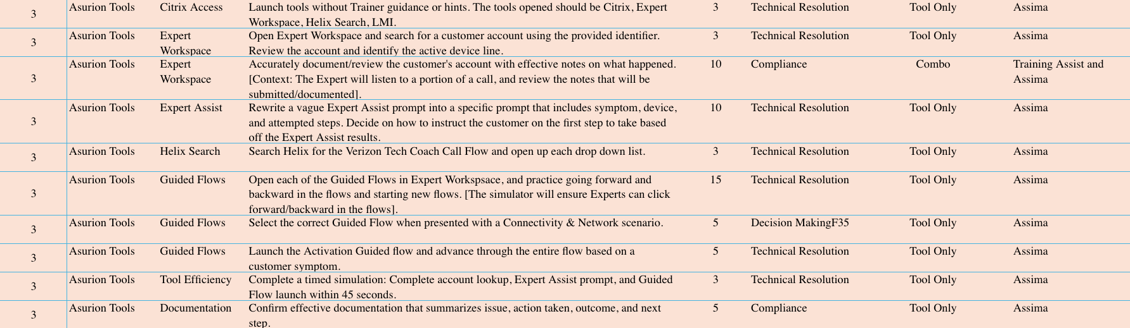

  - Instructional Design Guidance
For every course within this learning block, instructional designers should define:
- Content: What information is delivered.
- Modality: How the learning is delivered (ILT, CBT, simulation, activity, etc.).
- Practice: How Experts apply the knowledge or skill.
- Performance Check: How proficiency is demonstrated.
- Minimum Readiness Criteria: The observable behaviors or outcomes required before progressing to the next learning block.

Learning Block 4: Tools for the Call Flow- Client Tools
  - Purpose of the learning block
The Client Tools learning block introduces Experts to ACSS, TRG, and InfoManager as connected systems used to support customer interactions. By the end of the block, Experts should be able to identify the information or action needed, select and navigate the appropriate client tool, interpret account information and workflow prompts, and determine the correct next step. Experts will also practice following required processes, using approved information instead of guessing, and protecting customer information, creating a foundation for more complex tool use in later learning blocks.
  - Learning Objectives
By the end of this learning block, Experts will be able to:
- Explain the purpose of ACSS, TRG, and InfoManager and select the appropriate client tool or tool sequence based on the customer’s need.
- Navigate ACSS to locate and interpret the customer, account, line, device, status, alert, history, and note information required by the scenario.
- Use TRG to select the appropriate issue path, enter required information, follow prompts in sequence, and identify the tool-directed next step.
- Search InfoManager to locate current approved client guidance and apply it to the customer’s situation.
- Determine when an alert, policy, scope requirement, conflicting result, or unsupported tool path requires a different approved resource, fallback process, or escalation.
- Protect customer information, document required interaction details accurately, and keep the customer informed while using client tools.
  - Key Questions Answered:
Upon completion of this learning block, Experts should be able to answer:

Client Tool Ecosystem
- What are ACSS, TRG, and InfoManager used for?
- How do ACSS, TRG, and InfoManager work together with the Asurion tools introduced in the previous learning block?
Tool Selection and Use
- How do Experts identify the information or action needed and select the appropriate client tool?
- When should Experts use ACSS, and what account information or client workflows does it support?
- When is TRG required, and how should Experts follow its prompts?
- When should Experts use InfoManager, and how do they locate current approved client information?
- What information or tool result confirms the appropriate next step?
Information Protection and Process Compliance
- How do Experts protect customer information while navigating, searching, documenting, and practicing in client tools?
- How do Experts follow required workflows and prompts without skipping or bypassing process steps?
Tool-Path Recovery
- What should Experts do when a tool is unavailable, a search does not provide an answer, information appears inconsistent, or a workflow does not match the customer’s situation?
- How do Experts determine when to try another approved resource, follow a fallback process, or seek additional support?
  - Core Capabilities
Upon successful completion of this learning block, Experts are prepared to:
- Support customer interactions by selecting and using the appropriate client systems to retrieve, interpret, and apply customer, account, and workflow information needed to determine the appropriate next action.
- Navigate client systems efficiently while following required workflows, policies, and support processes without bypassing required steps or relying on unsupported guidance.
- Use client tools and approved resources together to make accurate customer-impacting decisions, validate support paths, and communicate appropriate next steps.
- Protect customer information by consistently applying required security, privacy, and documentation practices while working within client systems.
- Adapt to changing customer situations by recognizing when client information, workflows, or system results require an alternate resource, fallback process, escalation, or transfer.
- Build the foundational client-system proficiency required to support verification, troubleshooting, activations, carrier account support, warranty and claims, and other customer workflows throughout the remainder of Launchpad.
  - Assessment Methods
- Knowledge Check
- Simulation
  - Training Assist
  - Assima-
    - ACSS
    - TRG
    - InfoManager
    - Expert Workspace- Guided Flows

  - Minimum Performance Expectations
- Successfully complete all 10 required Client Tools simulations, including successful re-demonstration of any skill requiring coaching before progressing.
- Independently access ACSS, TRG, InfoManager, and Guided Flows in 100% of evaluated tool scenarios without trainer assistance.
- Use a provided MDN to locate the correct customer account, identify the appropriate account role, determine line status, and access the required account information in 10 of 10 evaluated account lookup scenarios.
- Retrieve and accurately interpret billing, plan, usage, digital access, feature, and line-status information required to support the customer’s need in 9 of 10 evaluated customer scenarios.
- Complete required TRG workflows by selecting the appropriate issue path, following prompts in sequence, and identifying the supported next action in 9 of 10 evaluated workflow scenarios.
- Use InfoManager to locate the current approved client guidance and accurately communicate the resulting customer action or next step in 9 of 10 evaluated search scenarios.
- Complete both required activation workflow scenarios by entering the provided IMEI accurately, following the Activation Guided Flow, and confirming the appropriate outcome in 100% of evaluated activation scenarios.
- Maintain ownership of the customer interaction during 9 of 10 evaluated client-tool scenarios by explaining what is being checked, why it is being checked, and the expected next step while navigating client systems.
- Complete required documentation in 100% of evaluated documentation scenarios by accurately recording the customer issue, actions taken, outcome, and next step.
- Recover from unavailable tools, conflicting information, unsupported workflows, or unsuccessful searches in 9 of 10 evaluated scenarios by selecting the appropriate approved resource, fallback process, or escalation path.

  - Courses and Resources (~1.5 hours)
Course | Modality | Length | Stakeholder Review | Core Capabilities # | Simulations | High-Level Description
ACSS Foundations | CBT | 30 min | 8/11 | 1, 2, 3, 6, 7, 8, 9 | 7 | Introduces ACSS and its key navigation areas. Learners practice selecting the right customer, account, line, or device and locating relevant account information.
InfoManager Foundations | CBT | 20 min | ~8/18 | 1, 2, 5, 9 | 1 | Introduces InfoManager as the source for client-approved knowledge, policy, and process guidance. Learners practice accessing the tool and turning customer needs into effective search terms.
TRG Foundations | CBT | 30 min | ~8/18 | 1, 2, 4, 9 | 4 | This CBT introduces TRG as a guided troubleshooting and resolution tool. Learners practice choosing the right path, following prompts in order, responding to branches, and recovering when a flow does not fit.

  - Simulation Strategy (~1 hour 10 minutes)
Simulation should begin immediately after each tool module and progress from isolated navigation tasks to integrated customer-context scenarios. The purpose of this block is to build reliable tool habits before learners are expected to manage a complete customer interaction.
Use fictional customer and account information only. Unless verification is deliberately included after the Greeting + Verification block, every scenario should state that the customer is already verified until the final simulations where you are bringing it all together.

Total Simulations: 10

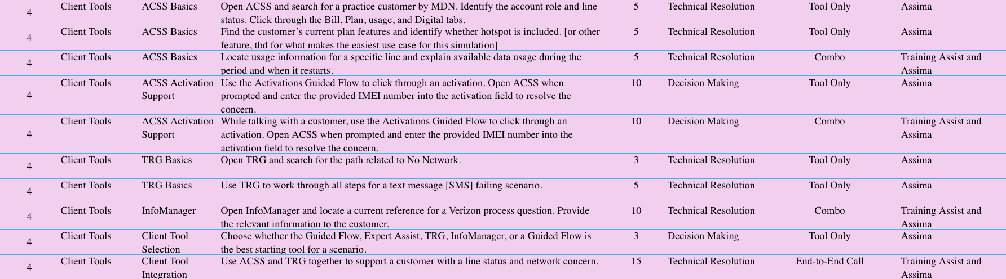

Learning Block 5: Sales Foundation- Product Knowledge, Compliance, & Integrity
  - Purpose of the learning block
The Sales Foundations learning block introduces Experts to the sales approach, Verizon Home Device Protect, and how the Serve, Solve, Sell model supports a customer-centered sales experience. By the end of the block, Experts should be able to explain the purpose of the Home Plan, identify when it may be relevant to a customer with eligible home technology, and describe how sales can follow naturally after serving the customer and addressing their original need. This block establishes foundational product knowledge and sales awareness, while detailed Smart Offer steps, conversational practice, concern resolution, and closing will be developed later in Sales in Action.
  - Learning Objectives
By the end of this learning block, Experts will be able to:
- Explain the purpose, customer benefits, key plan details, and boundaries of Verizon Home Device Protect, including how it differs from mobile device protection.
- Use approved resources to verify current pricing, service fees, enrollment information, claim or service expectations, and other plan details before communicating them to the customer.
- Identify common home-technology needs and determine when Verizon Home Device Protect may be relevant based on information the customer shares.
- Ask probing questions and summarize the customer’s needs before connecting those needs to applicable plan benefits.
- Follow the Serve, Solve, Sell approach by addressing the customer’s original concern and confirming the resolution or next step before transitioning to a plan discussion.
- Describe Verizon Home Device Protect accurately and connect relevant value to the customer’s stated needs using clear, conversational language rather than a scripted or generic explanation.
  - Key Questions Answered
The learning block should help Experts answer the following questions:
- What is Serve, Solve, Sell?
- What is Verizon Home Device Protect?
- How is VHDP different from mobile device protection?
- Why is VHDP a fit for customers with eligible home technology?
- What products, benefits, services, and support areas should Experts understand at a foundational level?
- What are the key plan details, including price, service fees, claim or service limits, enrollment, and plan boundaries?
- What basic plan questions should Experts be able to answer?
- When is it appropriate to offer the plan to the customer?
  - When does the Transition Statement happen? (although we won’t get into all the specifics of Smart Offer, we will explain that this begins once we’ve fully resolved the customer’s concern).
- What sales compliance behaviors must stay visible throughout the interaction?

  - Core Capabilities
Upon successful completion of this learning block, Experts are prepared to:
- Recognize customer situations where Verizon Home Device Protect may provide relevant value based on the customer’s technology, needs, and information gathered during discovery.
- Communicate Verizon Home Device Protect accurately by explaining its purpose, benefits, coverage, and boundaries using approved information and customer-friendly language.
- Use approved resources as the primary source of truth to verify product details, pricing, eligibility, enrollment requirements, and other customer-impacting plan information before communicating recommendations.
- Apply the Serve, Solve, Sell philosophy by prioritizing resolution of the customer’s original need before introducing relevant product recommendations.
- Maintain customer trust by presenting product information with integrity, avoiding unsupported claims, compliance violations, or pressure-based selling behaviors.
- Build the foundational product knowledge and customer-value recognition required to successfully execute the Smart Offer process in Learning Block 14: Sales in Action.
  - Assessment Methods
- Knowledge Check
- Simulation
  - Roleplay Tool
  - Training Assist

  - Minimum Performance Expectations
- Successfully complete all 6 required Sales Foundation simulations, including successful re-demonstration of any skill requiring coaching before progressing.
- Correctly distinguish between Verizon Home Device Protect and Verizon Mobile Protect in 80% evaluated product comparison scenarios.
- Accurately explain the purpose, core benefits, enrollment boundaries, and intended customer use of Verizon Home Device Protect in 80% evaluated customer conversations using approved language.
- Use approved resources to verify pricing, service fees, enrollment requirements, coverage information, and plan details before communicating customer-impacting information in 100% of evaluated scenarios.
- Identify at least one relevant customer need that aligns with Verizon Home Device Protect in 80% evaluated customer scenarios.
- Connect at least one Verizon Home Device Protect benefit to the customer’s stated need using clear, conversational language in 80% evaluated customer scenarios.
- Confirm the customer’s original concern has been resolved or appropriate next steps have been established before introducing Verizon Home Device Protect in 100% of evaluated scenarios.
- Communicate Verizon Home Device Protect information without unsupported claims, inaccurate comparisons, compliance violations, or pressure-based selling behaviors in 100% of evaluated scenarios.
- Recognize when Verizon Home Device Protect is not an appropriate recommendation and continue supporting the customer’s original need without initiating a sales discussion in 80% evaluated scenarios.

  - Courses and Resources (~1.5 hours)
Course | Modality | Length | Stakeholder Review | Core Capabilities # | Simulations | High-Level Description
Home Plans (VHDP) and Insurance (VMP) | CBT | 15 min | ~8/18 | 1 | 1 | This CBT introduces our home plan, VHDP, and positions what a home plan is VS. Insurance, like the mobile insurance Verizon plan, VMP. It teaches the fundamentals and provides compliance and clarity around the important distinction between a home plan warranty and a mobile device insurance plan. It will also mention the Transition Statement that Experts will make, as it includes important supporting details, namely, "As I mentioned earlier, the Verizon Home Device Protect program is separate from your mobile device insurance..."
Verizon Home Device Protect (VHDP) Product Details | CBT | 30 min | 8/12 | 1-8 | 3 | This CBT introduces VHDP product and plan fundamentals. Learners explore each benefit of the plan in depth, enrollment, and where to verify plan details if unsure.
Sales Compliance for Everyone | CBT | 30 min | ~8/21 | 3, 8 | 2 | This required CBT reinforces compliant sales behaviors and informed customer decision-making. Learners review accurate product positioning, consent, unsupported claims, pressure tactics, and respecting the customer’s decision.
Sales Integrity Acknowledgment | CBT | 15 min | Current Course | 3, 8 | 2 | This required acknowledgment reinforces selling with integrity and prioritizing serve and solve. Learners confirm awareness of non-compliant behaviors, customer trust risks, and consequences for sales misconduct.

  - Simulation Strategy (~35 minutes)
Experts should be able to explain what a home plan is and how it is different from insurance. They should also be able to explain why a customer might enroll in VHDP and all the product details associated with VHDP.
They will move into progressive simulations that develop foundational sales capability. Simulations should gradually increase in complexity to develop the following in Experts:
- State accurate and compliant descriptions about VHDP.
- Correct themselves or a customer if VHDP is mischaracterized as insurance or described non-compliantly.
Total Simulations- 6
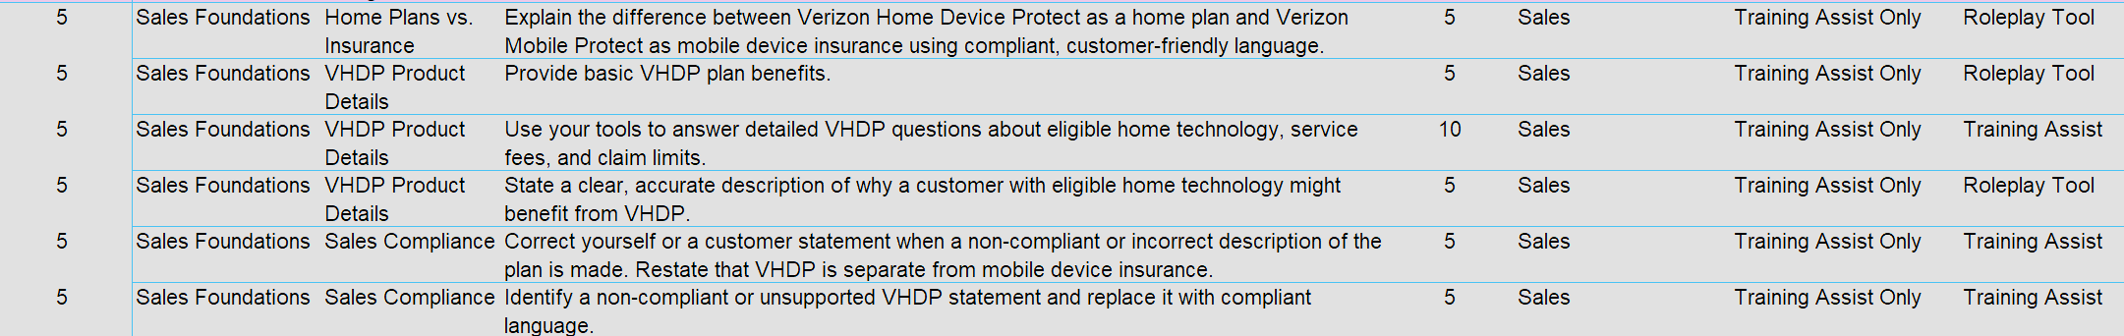

Learning Block 6: Call Flow Stage 1: Greeting, Verify, Assess, Empathy & Assurance

  - Purpose of the Learning Block
The Call Flow Part 1 learning block introduces Experts to the opening stage of a Verizon Tech Coach interaction, including the greeting, verification, account assessment, empathy, and assurance. By the end of the block, Experts should be able to deliver the approved greeting, select and complete the appropriate verification path, assess available account information, respond to customer concerns with empathy and credible assurance, and explain next steps when the expected verification method cannot be completed. Experts will practice connecting required security steps to a natural customer conversation while protecting account information, maintaining ownership, and preserving customer trust.
  - Learning Objectives
By the end of this learning block, Experts will be able to:
- Deliver the approved Verizon Tech Coach greeting accurately while maintaining a natural, conversational tone.
- Explain the purpose of verification in clear, customer-friendly language and transition confidently into the verification process.
- Identify the customer’s role, apply the appropriate authority and account-access rules, and select the correct approved verification method.
- Interpret the CVS screen to determine the verification status, available next action, and whether verification has been completed.
- Follow the approved exception path when a customer is unauthorized or cannot complete the expected verification method, while protecting account information and setting clear expectations.
- Demonstrate how to use verified account information and purposeful discovery questions to clarify the customer’s issue, impact, and desired outcome before selecting a support path.
- Respond to customer concerns with specific empathy and credible assurance without minimizing the experience or promising an unsupported outcome.
- Maintain control and forward movement during the opening stage of the interaction when the customer interrupts, expresses frustration, or cannot complete the expected verification path.
  - Key Questions Answered
The learning block should help Experts answer the following questions:
Greeting
- What elements of the Verizon Tech Coach greeting are required?
- Which parts of the greeting can be delivered naturally and conversationally?
- How do Experts confirm they are using the current approved greeting when the wording changes?
Verification Purpose and Customer Roles
- How do Experts explain verification so it feels protective rather than procedural?
- How does the customer’s role affect the verification path?
- How does the customer’s role determine what the Expert is authorized to access, discuss, or complete?
Verification Methods and CVS
- How do Experts select the appropriate approved verification method?
- How do Experts interpret the CVS screen to determine verification status and the correct next action?
- How do Experts confirm that verification is complete before accessing or discussing protected account information?
Verification Exceptions and Expectation-Setting
- What should Experts do when the customer is unauthorized or cannot complete adaptive authentication?
- How do Experts protect account information while managing a verification exception?
- How do Experts explain the available next steps without creating a dead end or suggesting that verification can be bypassed?
Account Assessment and Discovery
- How do Experts transition naturally from verification into account assessment and advanced discovery?
- How do Experts use verified account information and customer questions together without making premature assumptions?
Empathy and Assurance
- How do Experts acknowledge the customer’s specific concern or impact?
- How do Experts provide credible assurance without minimizing the customer’s experience or promising an unsupported outcome?
Readiness
- What observable behaviors demonstrate successful management of a happy-path verification scenario?
- What observable behaviors demonstrate successful management of an exception-path verification scenario?
- What does successful completion of the opening stage of the call flow look like?

  - Core Capabilities
Upon successful completion of this learning block, Experts are prepared to:
- Confidently initiate customer interactions by delivering a professional greeting, establishing rapport, and creating a positive first impression while maintaining the approved Verizon Tech Coach call flow.
- Protect customer information by selecting and completing the appropriate verification process based on customer role, account access, and approved security requirements.
- Use verified account information, purposeful discovery, and account assessment to accurately identify the customer’s need before selecting a support path.
- Maintain customer confidence throughout the opening stage of the interaction by demonstrating empathy, providing credible assurance, setting appropriate expectations, and communicating the next steps clearly.
- Maintain control of the customer interaction by effectively managing interruptions, verification exceptions, and customer frustration while following approved processes and preserving customer trust.
- Build the foundational customer engagement and verification skills required to support all subsequent troubleshooting, account support, activations, claims, and sales interactions throughout the remainder of Launchpad.
  - Assessment Methods
- Knowledge Check
- Simulation
  - Training Assist
  - Assima
    - Expert Workspace
    - ACSS

  - Minimum Performance Expectations
Experts must demonstrate the ability to:
- Successfully complete all 10 required Call Flow—Greeting and Verification simulations, including successful re-demonstration of any skill requiring coaching before progressing.
- Deliver the approved Verizon Tech Coach greeting with 100% of required components in all evaluated greeting scenarios, using a clear, engaged, and conversational tone.
- Introduce themselves as a Tech Coach, ask how they can help, and obtain the customer’s full name and phone number in 100% of evaluated call-opening scenarios using natural customer-friendly language.
- Correctly identify the whisper tone and select the appropriate call-opening path in 100% of applicable whisper-tone scenarios, where this routing remains in scope.
- Use the customer’s provided phone number and stated name to locate the correct account and select the correct customer contact in 100% of evaluated account-lookup scenarios, with zero wrong-account or wrong-contact selections.
- Successfully complete the approved happy-path verification process for both required customer roles in 2 of 2 evaluated scenarios:
  - Account owner.
  - Account manager.
- Successfully manage the verification exception in 1 of 1 evaluated adaptive-authentication scenario by:
  - Protecting all account information.
  - Declining to discuss protected account details when verification requirements are not met.
  - Avoiding unsupported verification workarounds.
  - Explaining that the account owner is required and setting clear next-step expectations.
- Complete account assessment only after verification is confirmed in 100% of applicable scenarios and use the verified account information to support the next stage of the interaction.
- Respond to the customer’s concern with relevant empathy and credible assurance in 100% of evaluated empathy scenarios, without minimizing the customer’s experience or promising an unsupported outcome.
- Successfully complete the integrated call-opening simulation with a score of at least 85% by:
  - Delivering the approved greeting.
  - Obtaining the customer’s name and phone number.
  - Locating the correct account and customer contact.
  - Completing the appropriate verification path.
  - Conducting account assessment after verification.
  - Responding to customer cues with empathy and assurance.
- Complete all evaluated activities with zero critical verification or customer-information errors, including:
  - Selecting the wrong account or customer contact.
  - Bypassing or incorrectly completing verification.
  - Accessing or disclosing protected account information before verification.
  - Continuing account support for an unauthorized customer.
  - Beginning account assessment before verification is complete.
  - Making an unsupported promise about verification or resolution.

  - Courses and Resources (~1.5 hours)
Course | Modality | Length | Stakeholder Review | Core Capabilities # | Simulations | High-Level Description
The Verizon Tech Coach Greeting | CBT | 15 min | 8/11 | 1, 9 | 4 | This CBT introduces the approved Verizon Tech Coach greeting and how to deliver it naturally. Learners practice required components, pacing, tone, and recovering when customers interrupt or begin with their issue.
Verification Protects Everyone | Video | 5 min | 7/30 | 2, 9 | 5 | This video explains verification as a customer protection step, not a barrier. Learners see how to explain the process clearly, reduce friction, follow approved paths, and maintain requirements during urgency or frustration.
Verification Overview | CBT | 35 min | ~8/18 | 3, 5, 9 | 5 | This CBT builds verification decision-making skills for role-based customer interactions. Learners practice choosing approved methods, interpreting CVS outcomes, recognizing restrictions, and responding when verification succeeds or fails.
Account Assessment | CBT | 20 min | 8/11 | 6 | 2 | This CBT connects successful verification to purposeful account review and issue discovery. Learners practice knowing when assessment begins, locating key ACSS information, and confirming understanding before troubleshooting.
Empathy and Assurance | Video | 5 min | 8/6 | 8 | 2 | This video builds purposeful empathy and assurance skills for customer interactions. Learners practice recognizing emotional cues, choosing credible language, and connecting their response to the next action.

  - Simulation Strategy (~45 minutes)
After completing the foundational video and CBT content, Experts should move into simulation-based practice. Simulations should give Experts the opportunity to apply what they learned in realistic customer scenarios.
The simulations should build in complexity over time. Experts should begin with initial greeting, verification, account assessment, empathy and assurance, then progress into scenarios with unauthorized users, failed verification, and escalated customers.
Total Simulations- 10
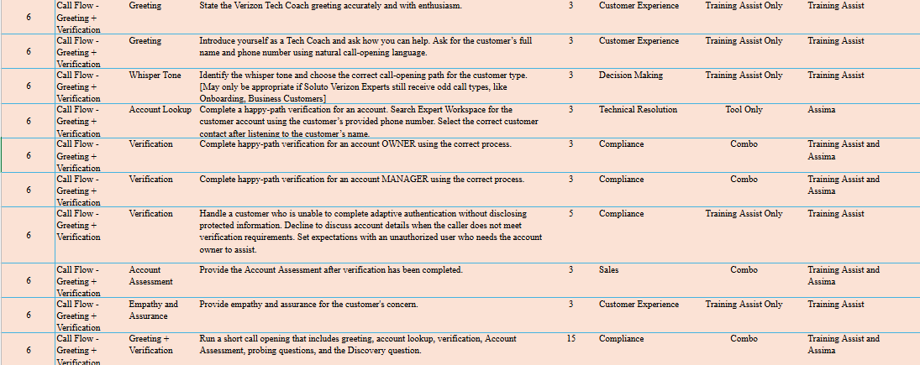

Learning Block 7: Call Flow Stage 2: Troubleshooting Basics
  - Purpose of the learning block
The Troubleshooting learning block introduces Experts to the Discover and Diagnose stage of the Verizon Tech Coach call flow. By the end of the block, Experts should be able to use Advanced Discovery and purposeful probing questions to clarify the customer’s concern, distinguish the reported symptom from a likely root cause, and select the appropriate troubleshooting tool or workflow. Experts will practice following approved steps, using customer responses to adjust the troubleshooting path, testing and confirming the outcome, and determining when to continue troubleshooting, pivot to another supported path, route to repair or replacement, escalate, or transfer. Throughout the process, Experts will maintain ownership by keeping the customer informed and clearly recapping the resolution, next steps, and expectations.
  - Learning Objectives
The proposed learning objectives for this learning block are:
- Apply the troubleshooting roadmap by gathering information, isolating the likely issue, taking action with approved tools, testing the result, and repeating the process when needed.
- Demonstrate probing, clarifying questions, and active listening to identify the customer’s issue, relevant context, previous attempts, and emotional or urgency cues.
- Differentiate the reported symptom from the likely root cause and classify the concern as network, calls, messaging, voicemail, software, hardware, accessory, or connected-device related.
- Select and use the appropriate troubleshooting tools and workflows, create complete Expert Assist prompts, and follow tool-directed steps in sequence.
- Maintain ownership by adapting communication to the customer’s responses, setting expectations, and keeping the customer informed throughout troubleshooting.
- Ask relevant discovery questions that can relate to the issue during troubleshooting that can be used for the offer as part of the Sell.
- Test the original concern and determine whether to confirm resolution, continue troubleshooting, pivot to another supported path, or proceed to repair, replacement, escalation, or transfer.
- Close the interaction by recapping the concern, actions, outcome, and next steps and documenting the interaction accurately.

  - Key Questions Answered
The learning block should help Experts answer the following questions:
Troubleshooting Foundations
- Why do customers contact Asurion for troubleshooting support?
- What does troubleshooting mean in the Expert role?
- What does a successful troubleshooting interaction look like?
Discover and Diagnose
- What is Advanced Discovery, and when should Experts use it during troubleshooting?
- What is the difference between a customer-reported symptom and a likely root cause?
- What probing and clarifying questions should Experts ask before taking action?
- How should Experts use customer responses to determine the appropriate troubleshooting path?
Common Troubleshooting Concerns
- What common troubleshooting call types should Experts expect?
- How may the troubleshooting approach differ for network, calls, SMS/MMS, voicemail, apps or software, device or hardware, and connected-device concerns?
Tools and Workflow Selection
- Which tools and resources support troubleshooting?
- When should Experts use each troubleshooting tool or resource?
- How do Experts select and follow the appropriate workflow instead of relying on memory or guessing?
Resolve, Test, and Confirm
- How should Experts test the result of each troubleshooting action?
- How do Experts confirm whether the customer’s issue is fully resolved?
- How do Experts distinguish a confirmed resolution from a temporary change or incomplete result?
Path Adjustment and Next-Step Decisions
- What should Experts do when the first troubleshooting path does not resolve the concern?
- What should Experts do after all applicable troubleshooting paths have been completed?
- When should Experts continue troubleshooting, pivot to another supported path, route to repair or replacement, escalate, or transfer?
Customer Communication and Ownership
- How do Experts maintain ownership while guiding customers through technical steps?
- How do Experts keep customers informed about what is being checked and what will happen next?
- How do Experts explain technical guidance clearly without overwhelming the customer?
Resolution Recap and Expectations
- How should Experts recap the concern, troubleshooting actions, and outcome?
- How should Experts communicate remaining next steps, responsibilities, and customer expectations at the end of the interaction?

  - Core Capabilities
Upon successful completion of this learning block, Experts are prepared to:
- Diagnose customer concerns by using purposeful discovery, active listening, and structured troubleshooting to distinguish reported symptoms from likely root causes.
- Select and execute the appropriate troubleshooting workflow by using approved tools, resources, and guided processes to identify, test, and validate potential resolutions.
- Adapt troubleshooting decisions based on customer responses, tool outputs, and troubleshooting results while maintaining ownership of the customer interaction.
- Guide customers through technical troubleshooting by communicating clearly, setting expectations, explaining actions, and confirming outcomes throughout the troubleshooting process.
- Determine the appropriate next action by recognizing when to continue troubleshooting, change support paths, recommend repair or replacement, escalate, or transfer the interaction.
- Build the diagnostic thinking and troubleshooting capabilities required to confidently resolve technical customer concerns throughout the remainder of Launchpad.

  - Assessment Methods
- Knowledge Check
- Simulation
  - Training Assist
  - Assima
    - Expert Workspace
    - ACSS/TRG

  - Minimum Performance Expectations
Experts must demonstrate the ability to:
- Successfully complete all 13 required Troubleshooting simulations, including successful re-demonstration of any skill requiring coaching before progressing.
- Use open- and closed-ended probing questions and active listening to gather the customer’s device, symptom, timing, impact, and previously attempted steps before selecting a troubleshooting path in 100% of evaluated discovery scenarios.
- Ask the approved Discovery question and create complete Expert Assist prompts that include the device or application, issue, relevant context, and previously attempted troubleshooting in 100% of applicable scenarios.
- Select the appropriate Guided Flow or approved resource, follow required steps in sequence, and explain technical guidance in customer-friendly language in 100% of evaluated tool-based scenarios.
- Test the customer’s original concern and obtain confirmation of the outcome in 100% of scenarios where a resolution is reached before stating that the issue is resolved.
- Recover from an unsuccessful troubleshooting path by selecting another approved tool or workflow rather than repeating ineffective steps or guessing in 100% of evaluated path-recovery scenarios.
- Complete the approved transfer or escalation process in 2 of 2 evaluated scenarios by explaining the reason, setting expectations, and completing the appropriate handoff.
- Successfully complete all 3 Troubleshooting Integration simulations, including maintaining ownership and adapting communication when the customer is frustrated or the expected path changes.
- Achieve at least 85% on the final end-to-end Troubleshooting simulation by completing the interaction from greeting through discovery, troubleshooting, resolution confirmation, recap, and next steps.
- Complete all evaluated activities with zero critical process errors, including beginning troubleshooting without sufficient discovery, selecting an unsupported path, skipping required steps, transferring prematurely, or declaring resolution without testing.

  - Courses and Resources (~1.5 hours)
Course | Modality | Length | Stakeholder Review | Core Capabilities # | Simulations | High-Level Description
Intro to Troubleshooting | Video | 5 min | Current Course | 1 | 5 | This existing video introduces troubleshooting as a structured method for diagnosing and resolving customer concerns. Learners see how a consistent approach helps identify issues, guide next steps, and support resolution.
How to Troubleshoot Using Tools | CBT | 20 min | ~8/24 | 5, 6, 7, 8, 12 | 5 | This CBT builds tool-supported troubleshooting skills. Learners practice using approved resources to diagnose issues, follow the right flow, refine Expert Assist prompts, and validate the fix.
How to Use Active Listening While Troubleshooting | CBT | 20 min | ~8/24 | 9, 10, 11 | 1 | This CBT adapts Active Listening with LINDA for troubleshooting conversations. Learners practice recognizing customer cues, adjusting communication, and maintaining ownership while continuing the troubleshooting process.
When Troubleshooting Does Not Resolve the Issue | Micro-CBT | 15 min | ~8/24 | 13, 14 | 2 | This micro-CBT helps Experts recognize when troubleshooting has reached its limit. Learners practice confirming missed details, choosing the right next step, maintaining ownership, and recapping the outcome clearly.

  - Simulation Strategy (~1 hour 40 minutes)
Experts should practice troubleshooting as a structured loop: listen, probe, identify the likely root cause, use the correct tool or workflow, test the result, and decide the next step.
Simulations should progress from choosing a starting path to tool-supported troubleshooting, unresolved-issue decisioning, advanced discovery, documentation, and end-to-end calls.
Total Simulations- 13
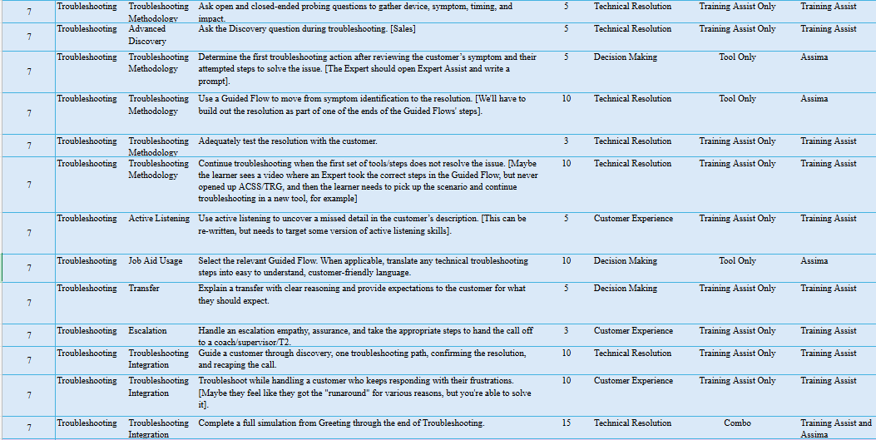

Learning Block 8: Call Flow Stage 2: Solve & Test - Device Basics
  - Purpose of the learning block
The Device Basics learning block introduces Experts to common Apple and Android devices and the resources used to provide accurate, device-specific support. By the end of the block, Experts should be able to identify the customer’s device, operating system, account ecosystem, and connected accessories; explain practical differences between iOS and Android; locate common settings; and use Ozmo and Expert Assist to validate guidance before providing instructions. Experts will also practice clarifying incomplete or imprecise device information and adjusting their guidance when the customer’s screen does not match the expected path, building practical device fluency without relying on memorization.
  - Learning Objectives
The proposed learning objectives for this learning block are:
- Identify the customer’s device, operating system, account ecosystem, and relevant connected accessories before providing guidance.
- Explain practical differences between iOS and Android that affect the customer’s device, settings, or intended action.
- Guide customers to commonly used device settings by providing clear, sequenced instructions and confirming they reach the intended location or outcome.
- Demonstrate how to Ozmo and Expert Assist to locate, validate, and apply accurate device-specific instructions rather than relying on memorized steps.
  - Key Questions Answered
The learning block should help Experts answer the following questions:
Device and Ecosystem Identification
- What device, operating system, and account ecosystem does the customer have?
- Is a connected watch, headset, or other accessory involved?
- Which account or ecosystem is connected to the customer’s concern?
- What practical differences between iOS and Android affect the customer’s goal?
Customer Need and Discovery
- What setting, feature, or device action does the customer need help completing?
- What information must Experts gather before providing device-specific instructions?
Tool and Resource Use
- How do Experts locate the correct device-specific path in Ozmo?
- How do Experts use Expert Assist to validate the guidance?
- How do Experts use approved resources instead of relying on memorized device paths?
Customer Guidance and Path Adjustment
- How do Experts explain device steps in clear, customer-friendly language?
- What should Experts do when the customer’s screen does not match the expected path?
- How do Experts adjust the guidance based on the customer’s device, operating system, or current screen?
Outcome Confirmation
- How do Experts confirm that the customer completed the intended action?
- How do Experts verify that the selected setting, feature, or device change produced the expected result?

  - Core Capabilities
Upon successful completion of this learning block, Experts are prepared to:
- Identify the customer’s device environment by recognizing the device type, operating system, ecosystem, and connected accessories needed to support the interaction.
- Guide customers through common device settings, features, and operating system functions using accurate, device-specific instructions supported by approved resources.
- Use Ozmo, Expert Assist, and other approved resources to validate device-specific guidance and provide accurate support without relying on memorization.
- Adapt customer guidance when device configurations, operating systems, or on-screen experiences differ from expected workflows while maintaining customer confidence and ownership.
- Confirm that customer actions produced the intended result before proceeding with additional troubleshooting or concluding the interaction.
- Build the foundational device knowledge and resource utilization skills required to support troubleshooting, activations, hardware and software diagnosis, and other device-specific customer interactions throughout the remainder of Launchpad.
  - Assessment Methods
- Knowledge Check
- Simulation
  - Training Assist
  - Assima
    - Expert Workspace
    - OZMO
    - Expert Assist

  - Minimum Performance Expectations
Experts must demonstrate the ability to:
- Successfully complete all 18 required Device Basics simulations, including successful re-demonstration of any skill requiring coaching before progressing.
- Identify the customer’s device manufacturer, model, operating system or software version, account ecosystem, connected accessories, and intended outcome before providing device-specific instructions in 100% of evaluated discovery scenarios.
- Correctly distinguish whether a concern involves a device setting, application account, Verizon account, ecosystem account, Bluetooth connection, smartwatch, accessory, or out-of-scope support need in 100% of evaluated classification scenarios.
- Use Ozmo and Expert Assist to locate and validate current device-specific guidance rather than relying on memorized settings paths in 100% of evaluated resource-use scenarios.
- Guide customers through iPhone and Android settings by providing steps in sequence, confirming each screen, and adjusting for manufacturer or software-version differences in 5 of 5 guided-navigation simulations.
- Identify the phone, smartwatch or accessory, companion application, account ecosystem, and connection method before beginning support in 4 of 4 connected-accessory simulations.
- Adapt the support path when the customer’s screen or pairing process does not match the initial guidance in 100% of evaluated path-recovery scenarios.
- Protect customer credentials in 100% of account- and ecosystem-related scenarios by distinguishing among device passcodes, Verizon credentials, application credentials, Apple IDs, and Google accounts without requesting passwords.
- Successfully complete all 3 Device Concerns capstone simulations with a score of at least 85% on each, including an iPhone setting concern, an Android path variation, and a phone-watch-account ecosystem concern.
- Confirm that the customer reached the intended setting, completed the requested action, or understands the supported next step in 100% of guided-navigation and capstone simulations.
- Complete all evaluated activities with zero critical device-support errors, including providing instructions for the wrong device, using unsupported guidance, exposing credentials, troubleshooting beyond the approved scope, or ending without confirming the outcome.

  - Courses and Resources (~35 minutes)
Course | Modality | Length | Stakeholder Review | Core Capabilities # | Simulations | High-Level Description
Common Devices | Video | 5 min | 8/6 | 1 | 20 | This video introduces common supported phone types and mobile ecosystems. Learners get a high-level view of Apple, Samsung, and other Android devices before comparing iOS and Android.
Device Basics – iOS vs. Android | CBT | 30 min | ~8/18 | 2, 3, 4, 5 | 20 | This CBT builds practical iOS and Android device knowledge for customer support. Learners compare common features, account types, settings, and how to use Ozmo and Expert Assist for device-specific guidance.  This CBT will end with a Formative Knowledge Check reinforce iOS vs. Android differences, Ozmo and Expert Assist use, path validation, and what to do when the customer’s screen does not match..

  - Simulation Strategy (~2 hour 30 minutes)
Experts should practice identifying the customer’s device, operating system, ecosystem, and connected accessories before giving instructions.
Simulations should then build into settings navigation, use of Ozmo and Expert Assist, path recovery when screens differ, accessory concerns, resolution confirmation, and documentation.
Total Simulations- 20
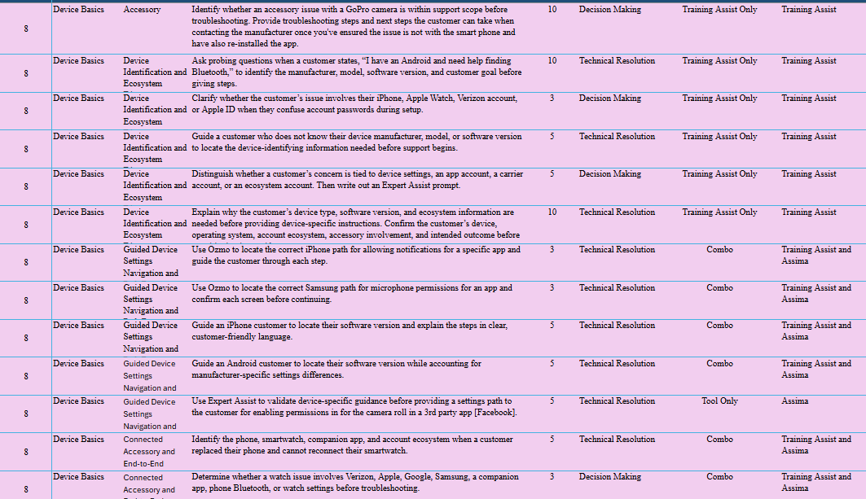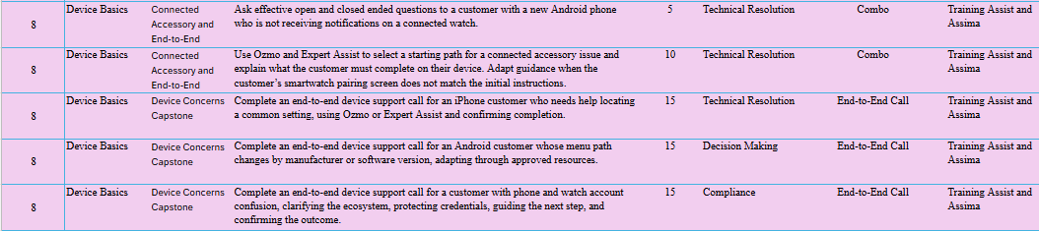

Learning Block 9: Call Flow Stage 2: Solve & Test - Hardware vs Software
  - Purpose of the learning block
The Hardware vs. Software learning block introduces Experts to common hardware and software concerns within the solve and test stage of the call flow. By the end of the block, Experts should be able to clarify the customer’s reported symptom, gather relevant information, distinguish a likely hardware concern from a software concern, and use approved tools and resources to select the appropriate troubleshooting, repair or replacement, escalation, or transfer path. Experts will also practice explaining findings and next steps clearly, protecting customer information, and documenting the interaction accurately. The focus is on practical diagnosis and sound decision-making—not memorizing every possible issue or becoming a device repair specialist.
  - Learning Objectives
The proposed learning objectives for this learning block are:
- Identify common hardware and software components and classify customer concerns as hardware-related, software-related, both, or requiring additional discovery.
- Explain how hardware and software work together and how an issue with either may affect the customer’s device experience.
- Ask focused discovery questions to gather the customer’s symptoms, timing, conditions, recent changes, and troubleshooting steps already attempted.
- Use Ozmo, Expert Assist, and other approved resources to validate the appropriate device-specific troubleshooting path and next action.
- Evaluate customer responses and tool results before determining a likely issue type, avoiding a definitive diagnosis until required discovery and troubleshooting steps are complete.
  - Key Questions Answered
The learning block should help Experts answer the following questions:
Issue Identification and Discovery
- What is the customer actually experiencing?
- Does the concern affect one app, one feature, an accessory, or the entire device?
- Is the concern related to hardware, software, an accessory, or multiple factors?
- What probing questions will help Experts gather the relevant information?
Diagnosis and Root-Cause Validation
- What common causes should Experts consider without jumping to a conclusion?
- What is the likely root cause, and how should Experts validate it before taking action?
- How do Experts distinguish a customer-reported symptom from a confirmed cause?
Tools and Resolution Path
- Which approved tool, workflow, or knowledge resource should Experts use?
- What is the appropriate troubleshooting or resolution path?
- How do tool guidance and customer results determine the next action?
Scope and Next-Step Decisions
- Is the concern within the Expert’s scope?
- When should Experts continue troubleshooting, escalate, transfer, or move to repair or replacement support?
Customer Communication and Trust
- How do Experts keep the customer informed throughout discovery and troubleshooting?
- How do Experts explain findings, actions, and next steps in clear, customer-friendly language?
- How do Experts build trust without making unsupported promises or providing a premature diagnosis?
Customer Information and Data Protection
- How do Experts protect the customer’s information and data throughout the interaction?
- What safeguards must be followed before completing actions that may affect the device or customer data?
Resolution, Recap, and Documentation
- How do Experts confirm that the concern has been resolved?
- How do Experts communicate remaining next steps and verify customer satisfaction?
- How do Experts document the concern, actions taken, outcome, and next steps accurately?

  - Core Capabilities
Upon successful completion of this learning block, Experts are prepared to:
- Differentiate hardware, software, and accessory-related customer concerns by using purposeful discovery and approved resources to identify the most likely cause of the issue.
- Evaluate customer symptoms and determine the appropriate troubleshooting path before recommending corrective actions or next steps.
- Use approved diagnostic resources to validate troubleshooting decisions and avoid unsupported assumptions or premature conclusions.
- Guide customers through hardware and software troubleshooting while communicating clearly, setting expectations, and maintaining ownership throughout the interaction.
- Determine when a customer concern can be resolved through troubleshooting and when repair, replacement, escalation, or another support path is more appropriate.
- Build the diagnostic decision-making skills required to accurately support hardware, software, and mixed-cause customer issues throughout the remainder of Launchpad.

  - Assessment Methods
- Knowledge Check
- Simulation
  - Training Assist
  - Assima
    - Expert Workspace
    - OZMO
    - Expert Assist
    - ACSS

  - Minimum Performance Expectations

Experts must demonstrate the ability to:
- Successfully complete all 15 required Hardware vs. Software simulations, including successful re-demonstration of any skill requiring coaching before progressing.
- Use probing questions to gather the affected app or device function, symptom or error, timing, recent changes, physical or liquid exposure, and previously attempted steps in 100% of evaluated discovery scenarios.
- Correctly determine whether a concern involves one app, multiple apps, device software, network connectivity, hardware, an accessory, or another support path in 100% of evaluated classification scenarios.
- Use Expert Assist, ACSS, and other approved resources to select and follow the supported troubleshooting path in 100% of evaluated tool-based scenarios rather than relying on assumptions or memory.
- Successfully complete all required app, browser, email, software-update, Bluetooth, battery, charging, and device-performance scenarios by explaining the steps clearly and confirming the result where testing applies.
- Complete both required frozen-screen scenarios by using the correct button-based restart process for the iPhone and Samsung Fold, without performing or recommending a factory data reset.
- Distinguish a likely hardware concern from a software or settings concern only after completing the required discovery and troubleshooting steps in 100% of evaluated hardware-decision scenarios.
- Set accurate expectations when device age, physical condition, or troubleshooting results indicate that maintenance steps may not fully resolve the concern or that repair or replacement support may be needed.
- Successfully complete the end-to-end battery-drain simulation with a score of at least 85% by completing discovery, approved tool use, troubleshooting, outcome validation, recap, and close.
- Complete all evaluated activities with zero critical device-support errors, including requesting customer passwords, providing instructions for the wrong device, performing an unsupported reset, making a premature hardware diagnosis, recommending an unsupported repair or replacement path, or ending without testing the original concern.

  - Courses and Resources (~1 hour)
Course | Modality | Length | Stakeholder Review | Core Capabilities # | Simulations | High-Level Description
Hardware vs Software | Video | 15 min | 8/12 | 1, 2, 3 | 15 | This video introduces the difference between hardware and software. Learners see how physical components and device settings or apps work together to help identify likely issue types.
Hardware and Software Concerns | CBT | 30 min | ~8/20 | 4, 5, 6 | 15 | This CBT builds recognition of common hardware and software concerns. Learners practice distinguishing symptoms from possible causes, asking focused discovery questions, and choosing the right troubleshooting starting point.  This CBT will end with a Formative Knowledge Check. . The check should reinforce symptom versus cause, focused discovery questions, approved resource use, avoiding premature diagnosis, and selecting the right troubleshooting or next-step path before simulations.

  - Simulation Strategy (~3 hours)

Working on updating the simulations since we pivoted today. After the video and CBT, Experts should practice identifying whether customer concerns are hardware-related, software-related, accessory-related, or caused by multiple factors.

Simulations should build from simple symptom identification to more complex troubleshooting and decision-making. Experts should practice asking focused discovery questions, using approved tools and resources, selecting the correct troubleshooting path, validating outcomes, and determining the right next step.

Scenarios should include common concerns such as frozen screens, battery drain, charging issues, Bluetooth/accessory pairing, app issues, email or browser issues, carrier app access, device slowness, updates, permissions, settings, storage, and connectivity.

Total Simulations- 15
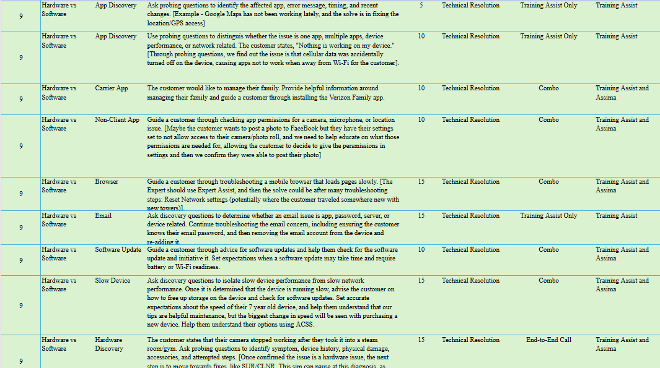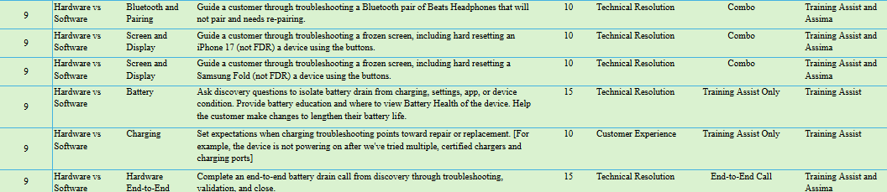

Learning Block 10: Call Flow Stage 2- Solve & Test- Networking

  - Purpose of the learning block

The Networking learning block introduces Experts to common network-related concerns within the solve and test stage of the call flow. By the end of the block, Experts should be able to gather relevant information, distinguish customer-reported symptoms from likely root causes, identify connectivity patterns, and select the appropriate troubleshooting path using Guided Flows and approved Verizon tools. Experts will practice using tool guidance to validate their decisions, adjusting the path based on customer responses and troubleshooting results, and testing whether the concern is resolved. Throughout the process, Experts will maintain ownership by asking purposeful probing questions, actively listening, showing empathy and assurance, and keeping the customer informed.

  - Learning Objectives

The proposed learning objectives for this learning block are:
- Classify common network concerns and distinguish the customer-reported symptom from the likely root cause.
- Ask purposeful probing questions to identify the affected device or service, timing, location, frequency, recent changes, and troubleshooting steps already attempted.
- Demonstrate how to use customer responses and troubleshooting patterns to narrow the probable cause and select the appropriate starting path.
- Initiate and follow the appropriate Guided Flow and use ACSS, TRG, and other approved tools to complete required troubleshooting steps in sequence.
- Evaluate customer and tool results to determine whether to continue troubleshooting, return to an earlier decision point, or pivot to another supported path.
- Explain troubleshooting steps in clear, customer-friendly language, set expectations, and maintain confidence and ownership when the concern is unclear or the first path is unsuccessful.
- Test the customer’s original concern and confirm whether the issue is resolved or requires another supported next step.

  - Key Questions Answered

The learning block should help Experts answer the following questions:

Network Concern Identification
- What qualifies as a network concern?
- How do Experts distinguish among different types of network problems?

Diagnosis and Pattern Recognition
- How do Experts separate the customer-reported symptom from the likely root cause?
- What patterns help Experts narrow the concern based on the affected device, service, connection type, or location?

Tool and Workflow Selection
- Which approved tools and resources support network troubleshooting?
- When should Experts use the Network and Connectivity Guided Flow, ACSS, TRG, or another approved resource?

Path Adjustment
- What should Experts do when the initial hypothesis or troubleshooting path is incorrect?
- How do customer responses and tool results determine whether to continue, return to an earlier decision point, or select another supported path?

  - Core Capabilities

Upon successful completion of this learning block, Experts are prepared to:
- Diagnose common network-related customer concerns by recognizing troubleshooting patterns, interpreting customer symptoms, and identifying likely root causes.
- Use approved network troubleshooting tools and workflows to validate assumptions, isolate issues, and determine the appropriate resolution path.
- Adjust troubleshooting decisions based on customer responses, diagnostic results, and changing network conditions while maintaining ownership of the interaction.
- Guide customers through network troubleshooting by communicating technical information in clear, customer-friendly language and setting appropriate expectations throughout the interaction.
- Determine when network concerns require continued troubleshooting, an alternate workflow, escalation, transfer, or another supported resolution path.
- Build the network troubleshooting and diagnostic capabilities required to confidently resolve connectivity-related customer concerns in production.

  - Assessment Methods
- Knowledge Check
- Simulation
  - Training Assist
  - Assima
    - Expert Workspace
    - Guided Flow
    - ACSS/TRG

  - Minimum Performance Expectations

Experts must demonstrate the ability to:

- Successfully complete all 13 required Networking simulations, including successful re-demonstration of any skill requiring coaching before progressing.
- Use probing questions to identify whether the concern affects data, calls, messaging, hotspot, or multiple services and determine whether it is intermittent, location-specific, device-specific, or broader in 100% of evaluated discovery scenarios.
- Confirm relevant recent changes—including a new device, travel, settings changes, or plan changes—before selecting a network troubleshooting path in 100% of applicable scenarios.
- Complete all 3 Network and Connectivity Guided Flow activities by selecting the correct path for slow data, calling, or messaging concerns, following prompts in sequence, and identifying the supported next action.
- Complete the required No Network, Emergency Calls Only, or SOS scenario by checking account status and following the approved TRG path without skipping required steps.
- Use ACSS, ExWo, TRG, Expert Assist, and other approved resources when directed in 100% of evaluated tool-based scenarios rather than guessing or bypassing the workflow.
- Successfully complete all 6 service-specific troubleshooting scenarios involving mobile data, network settings, outgoing calls, SMS, MMS or group messaging, and hotspot connectivity.
- Test the customer’s original concern in 100% of applicable scenarios by completing the appropriate live validation, such as placing a call, sending a message, loading new content over mobile data, or testing hotspot connectivity.
- Continue through another approved tool or troubleshooting path when the first action is unsuccessful rather than repeating ineffective steps or assuming the issue is resolved.
- Complete the required network-transfer scenario by confirming that supported troubleshooting has been exhausted, explaining why the transfer is needed, setting expectations, and initiating the approved transfer path.
- Successfully complete the end-to-end slow-data simulation with a score of at least 85% by completing discovery, Guided Flow and TRG use, troubleshooting, resolution testing, recap, and close.
- Complete all evaluated activities with zero critical network-support errors, including skipping required account checks, selecting an unsupported path, performing an unnecessary reset, declaring resolution without testing, or transferring before supported troubleshooting is exhausted.

  - Courses and Resources (~1 hour)

Course | Modality | Length | Stakeholder Review | Core Capabilities # | Simulations | High-Level Description
Understanding the Network | Video | 15 min | 8/11 | 1 | N/A- this is an intro to help Experts understand different network connections | This video introduces basic network concepts and common connection types. Learners see how Bluetooth, Wi-Fi, cellular, hotspot, and NFC connections support devices and affect the customer experience.
Understanding Network Concerns | CBT | 30 min | ~8/20 | 1-9 | 13 | This CBT builds pattern recognition for common network concerns. Learners explore internet, calls, messaging, and voicemail issues while practicing discovery and choosing the right troubleshooting tools.  This CBT will end with a formative knowledge check reinforce diagnostic thinking, tool selection, and clear customer communication before simulations.

  - Simulation Strategy (~2 hours)

Experts should be able to investigate ambiguous network concerns, identify the most probable root cause through purposeful probing, validate their reasoning using the appropriate troubleshooting tools, and confidently guide customers toward resolution while maintaining trust throughout the interaction.

They will move into progressive simulations that develop troubleshooting capability. Simulations should gradually increase in ambiguity to develop the following in Experts:
- Listening to customer concerns
- Probing for the cause of the issue
- Using diagnostic tools and test assumptions
- Communicating effectively with the customer with empathy and assurance
- Using tools to Troubleshoot and adjusting decisions

Total Simulations- 13

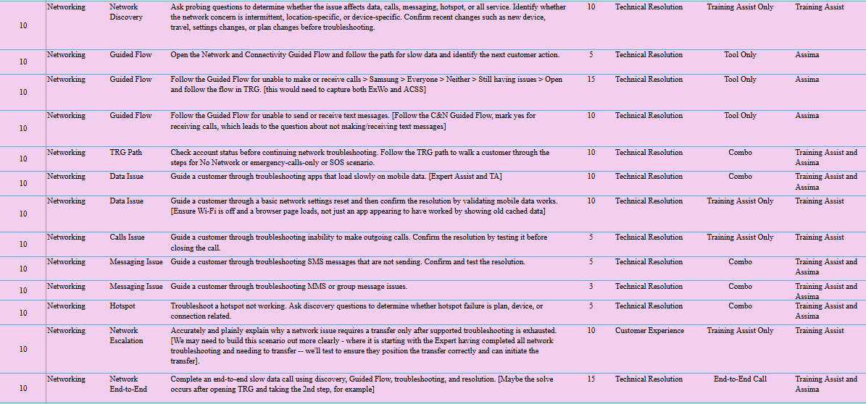
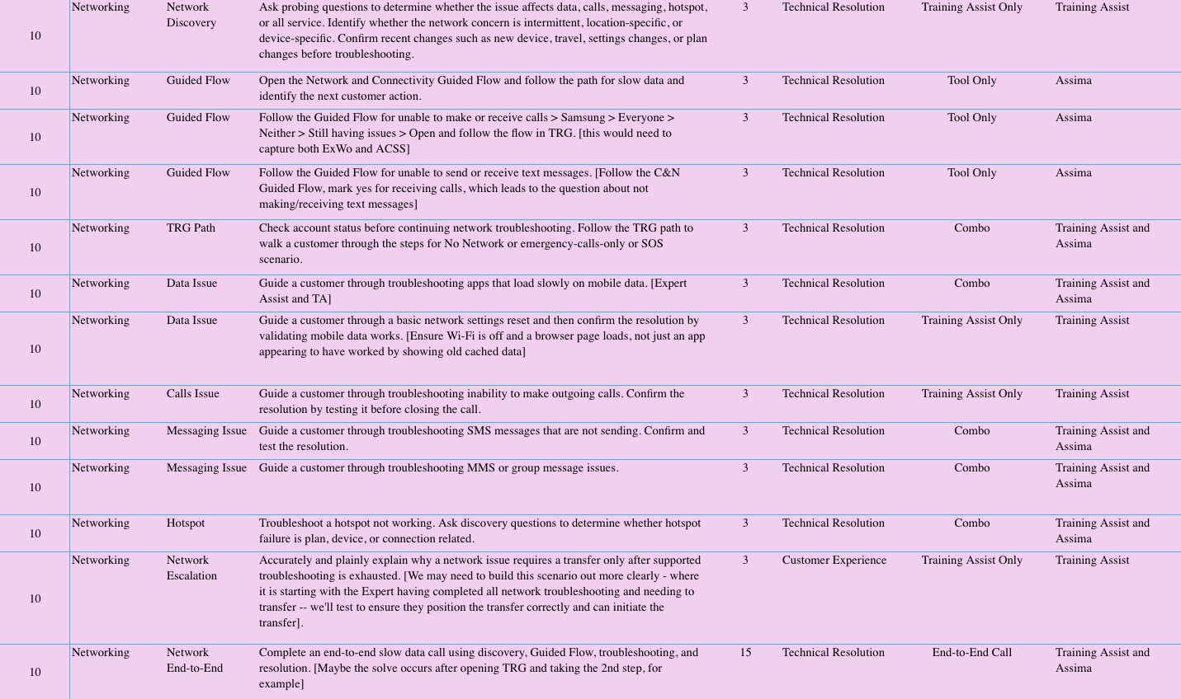

Learning Block 11: Call Flow Stage 2- Solve & Test- Activations and Device Onboarding

  - Purpose of the learning block

The Activations learning block introduces Experts to common device activation scenarios within the solve and test stage of the call flow. By the end of the block, Experts should be able to identify the type of activation and where the customer is in the process, ask purposeful probing questions, select and follow the appropriate tools and workflow, and guide the customer through the required activation steps. Experts will also practice adjusting the path when the expected process does not work, troubleshooting activation errors with approved resources, confirming that activation is complete, and clearly communicating any remaining next steps.

  - Learning Objectives

Proposed learning objectives for the learning block:
- Explain what device activation is, why it matters to the customer experience, and the responsibilities of both the Expert and the customer during the process.
- Demonstrate how to ask purposeful probing questions to identify the customer’s activation need, activation origination, device type, and current point in the process.
- Select and use the appropriate activation tools, including Activation Guided Flow, ACSS, TRG, and Activation Resolver, based on the customer’s situation.
- Guide the customer through the correct activation path for iPhone, Samsung, other Android devices, Apple Watch, Samsung Watch, or Gizmo Watch.
- Demonstrate use of customer responses and tool results to identify activation errors, determine why the expected path failed, and select the appropriate troubleshooting, alternate-tool, or escalation path.
- Test and confirm that activation was completed successfully and clearly communicate the outcome, remaining customer actions, and next steps.
- Guide a customer through an end-to-end content transfer across supported devices and approved transfer methods by identifying old and new device, selecting the correct transfer path, explaining each step clearly, adapting when the expected path differs, and confirming that the intended content transferred successfully.

  - Key Questions Answered

The learning block should help Experts answer the following questions:

Activation Foundations
- What is device activation?
- Why do customers contact Asurion for activation support?
- What does a successful activation look like?

Expert and Customer Roles
- What is the Expert’s role during an activation?
- What actions or information may the customer need to provide during the activation process?
- How do Experts guide the customer while allowing them to complete customer-owned actions?

Discovery and Path Selection
- What probing questions should Experts ask to understand the customer’s activation need?
- How do Experts identify the activation origination, device type, and customer’s current point in the process?
- How do Experts determine the correct activation path?

Activation Tools and Device Paths
- Which tools support device activations?
- When should Experts use Activation Guided Flow, ACSS, TRG, or Activation Resolver?
- How does the activation process differ for phones and watches?
- How do activation paths vary across iPhone, Samsung, other Android devices, Apple Watch, Samsung Watch, and Gizmo Watch?

Error Handling and Path Recovery
- What common problems or errors can occur during activation?
- What should Experts do when the expected activation path does not work?
- How do customer responses and tool results help Experts determine why an activation failed?
- When should Experts continue troubleshooting, select another approved tool, or escalate?

Outcome Confirmation
- How do Experts test and confirm that activation was completed successfully?
- How do Experts explain the outcome, remaining customer actions, and next steps clearly?

Content Transfer
- What information about the source device, destination device, operating systems, accounts, and intended content must be gathered before starting?
- How do Experts select the appropriate approved transfer method for the customer’s devices and situation?
- What preparation is required before the transfer begins?
- Which transfer actions must remain under the customer’s control, and how should Experts protect customer data and credentials?
- How do Experts provide clear, step-by-step guidance and set expectations throughout the transfer?
- What should Experts do when the expected method is unavailable, the screens do not match, or only some content transfers?
- How do Experts confirm that the intended content transferred successfully and communicate any remaining next steps or limitations?

  - Core Capabilities

Upon successful completion of this learning block, Experts are prepared to:

- Support customer activations by identifying the activation scenario, selecting the appropriate workflow, and guiding customers through successful device activation and onboarding.
- Use approved activation tools and workflows to validate activation status, resolve common activation issues, and determine the appropriate next action.
- Adapt activation support based on device type, customer situation, activation results, and troubleshooting outcomes while maintaining ownership of the interaction.
- Guide customers through activation, onboarding, and content transfer activities by communicating clearly, setting expectations, and confirming successful completion throughout the process.
- Determine when activation issues require additional troubleshooting, alternate workflows, escalation, or transfer to another support path.
- Build the activation and device onboarding capabilities required to confidently support new devices, replacement devices, content transfers, and activation-related customer interactions throughout production.

  - Assessment Methods
- Knowledge Check
- Simulation
  - Training Assist
  - Assima
    - Expert Workspace
    - Guided Flow
    - ACSS & TRG

  - Minimum Performance Expectations

Experts must demonstrate the ability to:
- Successfully complete all 35 required Activations and Device Onboarding simulations, including successful re-demonstration of any skill requiring coaching before progressing.
- Identify the activation type, device, origination reason, and correct MDN before beginning activation steps in 100% of evaluated activation-discovery scenarios.
- Select and follow the correct Activation Guided Flow and supporting ACSS or TRG path in 100% of evaluated tool-based activation scenarios.
- Successfully complete all 5 required happy-path activation scenarios for:
  - iPhone.
  - Android phone.
  - Apple Watch.
  - Samsung Watch.
  - Gizmo Watch.
- Recover successfully in 11 of 11 activation-exception scenarios, including eSIM failure, QR-code failure, wrong-number activation, SOS or No Service, failed phone or watch activation, and an end-to-end activation requiring a pivot.
- Confirm activation success in 100% of applicable scenarios by testing calling, texting, and mobile-data functionality before closing.
- Select and guide the appropriate content-transfer method in 3 of 3 dedicated transfer scenarios involving iPhone, Samsung Smart Switch, and Android or Google backup.
- Respond appropriately in 3 of 3 content-transfer barrier scenarios involving an unavailable source device, an extended transfer time, or an unknown backup password.
- Protect customer credentials and keep account sign-in, password entry, and other customer-owned actions under the customer’s control in 100% of onboarding and transfer scenarios.
- Complete the required new-device setup and education activities by guiding Wi-Fi connection, account sign-in, recommended settings, and navigation to contacts, messages, photos, and settings.
- Review and correct auto-generated notes in 1 of 1 documentation scenario so the record accurately reflects the issue, actions, outcome, and next steps.
- Successfully complete all 4 integrated activation and onboarding simulations with a score of at least 85% on each, including a happy-path activation, a failed activation requiring a pivot, a replacement-device activation with content-transfer support, and a customer concerned about losing content.
- Complete all evaluated activities with zero critical activation, customer-data, or documentation errors, including activating the wrong line, bypassing required workflow steps, exposing credentials, promising that all content will transfer, declaring activation complete without testing, or submitting inaccurate notes.

  - Courses and Resources (~2 hours)

Course | Modality | Length | Stakeholder Review | Core Capabilities # | Simulations | High-Level Description
Activation Overview | Video | 10 min | 8/12 | 1 | N/A- overview video | Introduce activations at a high level, including what activation means, why customers need support, and where activation needs may originate, such as replacement devices, new devices, or onboarding. It should focus on the happy path first so Experts understand successful activation before learning exceptions.
Expert Role, Customer Role, and Tool Intro | CBT | 20 min | ~8/24 | 2, 3, 4 | 3 | Clarify the Expert’s role, the customer’s role, and the tools used during activation support. Experts should learn what they guide, verify, and explain; what the customer may need to complete; and when to use the Activation Guided Flow, ACSS, TRG, or Activation Resolver.
Activation Process | CBT | 30 min | ~8/24 | 5, 6, 7, 8, 9,10, 11 | 16 | Teach the standard phone activation process and how steps may vary by device type or scenario. Experts should learn activation paths for Apple, Samsung, other Android devices such as Google Pixel, and Gizmo Watches, along with key decision points and signs that the happy path has stopped working.  Educate Experts how to respond when activation does not follow the happy path. Experts should learn common failure patterns, how to identify why activation failed, and how to use the Activation Guided Flow, ACSS, TRG, and Activation Resolver to pivot before escalating too early.  This CBT will end with a formative knowledge check.
Content Transfer Fundamentals | Video | 15 min | Current Course | 12 | 11 | Teach Experts how to think through content transfer instead of memorizing every path. It should cover common transfer needs, backup versus restore, direct transfer, cloud or account sync, app-based transfer, key probing questions, and major transfer paths across iOS, Android, Samsung, Verizon Cloud, Google, iCloud, and computer backup.

  - Simulation Strategy (~5 hours)

After completing the foundational video and CBT content, Experts should move into simulation-based practice. Simulations should give Experts the opportunity to apply what they learned in realistic customer scenarios.
Each simulation should have a unique ID number so scenarios can be tracked, assigned, updated, and referenced consistently.
The simulations should build in complexity over time. Experts should begin with initial probing and happy-path activation scenarios, then progress into scenarios that include errors, failed activations, and device-specific complexity.

Total Simulations- 35

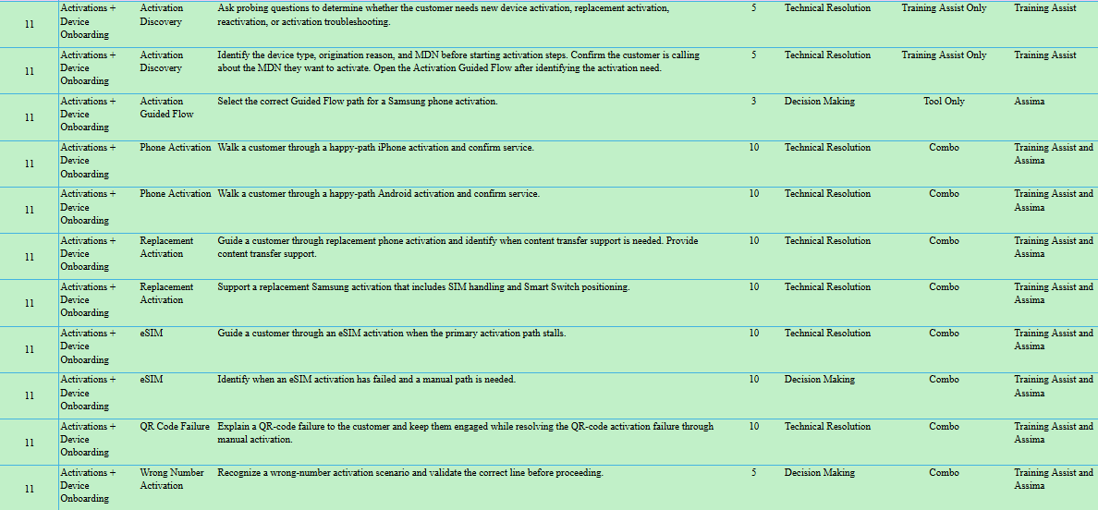
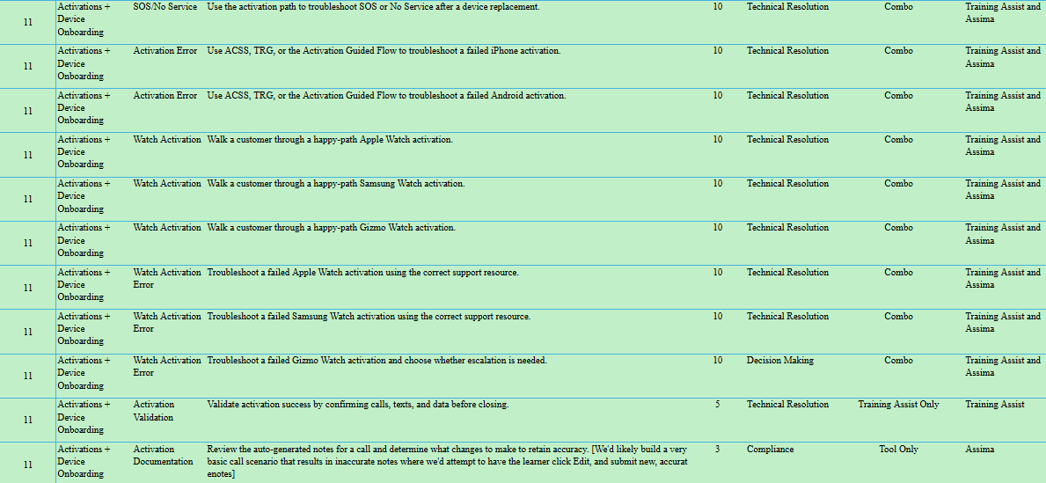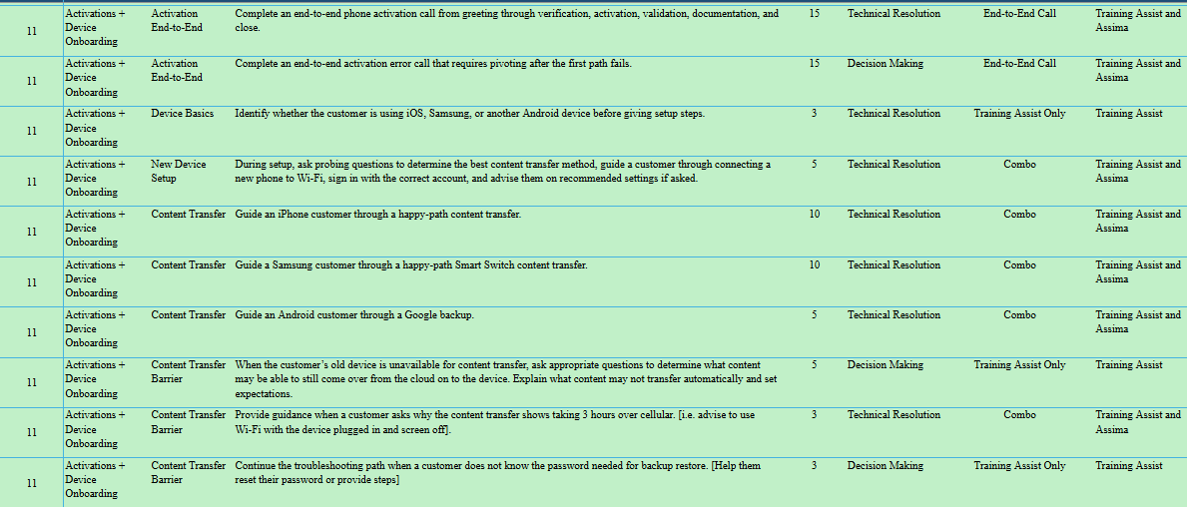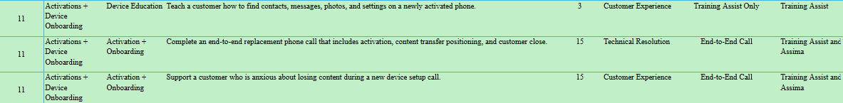

Learning Block 12: Call Flow Stage2: Solve & Test - Carrier Account

  - Purpose of the Learning Block

The Carrier Account learning block introduces Experts to common Verizon account concerns within the solve and test stage of the call flow. By the end of the block, Experts should be able to identify the customer’s account need, select the appropriate support path, and use myVerizon, ACSS, Guided Flows, and approved resources to locate information, complete supported workflows, and determine the correct next step. Experts will spend most of the learning block applying these skills through realistic Training Assist and Assima simulations involving account research, billing review, self-service guidance, tool integration, and blocked-path decision-making. Throughout each interaction, Experts will practice protecting customer information, explaining account findings clearly, confirming the result, and setting accurate expectations before closing or transferring the interaction.

  - Learning Objectives

By the end of this block, Experts should be able to:
- Classify common Verizon account concerns, including billing, payments, plans, features, usage, digital access, PIN or password support, account-manager requests, line status, plan changes, and payment arrangements.
- Ask purposeful questions to identify the customer’s goal, affected line, current account state, and desired outcome before selecting a support path.
- Determine whether the customer’s concern should be addressed through myVerizon self-service, ACSS research, a Guided Flow, another approved resource, or transfer.
- Navigate the ACSS Bill, Plan, Usage, and Digital areas to locate and interpret the account information required for the customer’s concern.
- Guide supported myVerizon actions while keeping security, authentication, consent, and account-control steps with the customer.
- Explain account findings and supported actions in clear, customer-friendly language without guessing or promising an outcome that has not been confirmed.
- Adjust the support path when the initial workflow does not resolve the concern and confirm the account state, line status, completed action, or next step before closing the interaction.

  - Key Questions Answered

The learning block should help Experts answer the following questions:

Account Concern Identification
- What account concern is the customer contacting Asurion about?
- What information must Experts gather to understand the customer’s goal, affected line, account status, and desired outcome?

Tool and Support Path Selection
- Should the Expert use myVerizon, ACSS, a Guided Flow, another approved resource, or a transfer path?
- How do Experts determine the best starting path for the customer’s account concern?

Self-Service and Customer Responsibilities
- Which account actions can Experts guide through myVerizon self-service?
- Which security, authentication, consent, or account-control actions must the customer complete themselves?
- How do Experts support self-service while keeping the customer in control?

Account Research and Customer Explanation
- Where should Experts locate billing, plan, usage, digital-access, feature, or line-status information?
- How should Experts explain account findings, billing terms, plan features, account status, and next steps in clear, customer-friendly language?
- How do Experts avoid guessing or promising an account outcome that has not been confirmed?

Path Recovery
- What should Experts do when the first tool, self-service process, or workflow does not resolve the concern?
- When should Experts select another approved resource, use a Guided Flow, or transfer the customer?

Outcome Confirmation
- What account state, line status, action, or next step should Experts confirm before ending the interaction?
- How should Experts recap what was completed, what remains, and what the customer should expect next?

  - Core Capabilities

Upon successful completion of this learning block, Experts are prepared to:
- Support common carrier account requests by identifying customer needs, selecting the appropriate workflow, and guiding customers through supported account-related activities.
- Use carrier account tools, approved resources, and self-service options to accurately research, interpret, and communicate account information.
- Determine the appropriate support path by distinguishing between actions that can be completed by the Expert, guided through self-service, or require escalation or transfer.
- Explain account information, billing details, plan features, usage, and next steps using clear, customer-friendly language while maintaining customer ownership throughout the interaction.
- Adapt account support based on customer goals, account status, workflow outcomes, and available support options while maintaining compliance and minimizing customer effort.
- Build the carrier account support capabilities required to confidently resolve common account-related customer concerns in production.

  - Assessment Methods
- Knowledge Check
- Simulation
  - Training Assist
  - Assima
    - Expert Workspace
    - Guided Flow
    - ACSS

  - Minimum Performance Expectations

Experts must demonstrate the ability to:
- Successfully complete all 11 required Carrier Account simulations, including successful re-demonstration of any skill requiring coaching before progressing.
- Correctly classify the customer’s concern as billing, payment, plan, feature, digital access, PIN or password, or line-status related and navigate to the appropriate ACSS area in 100% of evaluated account-discovery scenarios.
- Guide all 5 required self-service and access activities involving myVerizon access, PIN or temporary-password support, payment, Caller ID preferences, and line suspension while keeping authentication and account-control actions with the customer.
- Confirm completion of the requested account action in 100% of applicable self-service scenarios, including verifying that a line has been suspended.
- Complete both required billing scenarios by locating and explaining the applicable bill information and correctly identifying when a credit request is outside the Expert’s scope.
- Explain account findings, billing information, and next steps in clear, customer-friendly language without guessing, promising a credit, or overstating the expected outcome.
- Use approved resources to provide accurate international-calling guidance in 1 of 1 account-maintenance scenario.
- Adjust the support path when myVerizon, ACSS, or the initial self-service process does not resolve the concern, using another approved resource or transfer path rather than guessing.
- Successfully complete both Carrier Account end-to-end simulations with a score of at least 85% on each, including:
  - A locked-out-of-myVerizon interaction from verification through restored access or an approved next step.
  - A billing interaction involving account review, explanation, expectation-setting, and close.
- Complete all evaluated activities with zero critical account, authorization, customer-data, or financial errors, including accessing the wrong account or line, requesting protected credentials, completing a customer-owned action, misrepresenting billing information, promising an unsupported credit, or confirming an action without validating the result.

  - Courses and Resources (~1 hour)

Course | Modality | Length | Stakeholder Review | Core Capabilities # | Simulations | High-Level Description
Intro to Carrier Account | Video | 10 min | 8/13 | N.A- Intro | 0 | Introduce the customer’s Verizon account, including how customers access account information through the app or web and how account roles affect what can be managed. It should set up why Experts need to identify the customer’s access level and account goal before choosing a support path.
Account Concerns | CBT | 30 min |  | 1-8 | 11 | Cover common account concerns and how Experts determine whether to use ACSS, the Carrier Account Guided Flow, myVerizon self-service, approved resources, or a transfer path. Experts should practice locating bill, plan, usage, digital access, feature, and line-status information, then explaining findings clearly while honoring customer-owned actions and support boundaries.  This CBT will end with a formative knowledge check.

  - Simulation Progression (~1 hour 15 minutes)

After the video and CBT, Experts should spend the remainder of the block in self-paced simulation practice.
The happy path should be practiced first. For Carrier Account, the happy path means the Expert identifies the account concern, chooses the correct workflow or tool, guides the customer through the supported path, confirms the result or next step, and avoids unnecessary transfer.
Simulations should then introduce common variants, such as a locked-out myVerizon customer, a bill that is higher than expected, a plan or feature question, a line suspension or reconnection request, a plan change request, or a PTP/payment arrangement request.

Total Simulations - 11
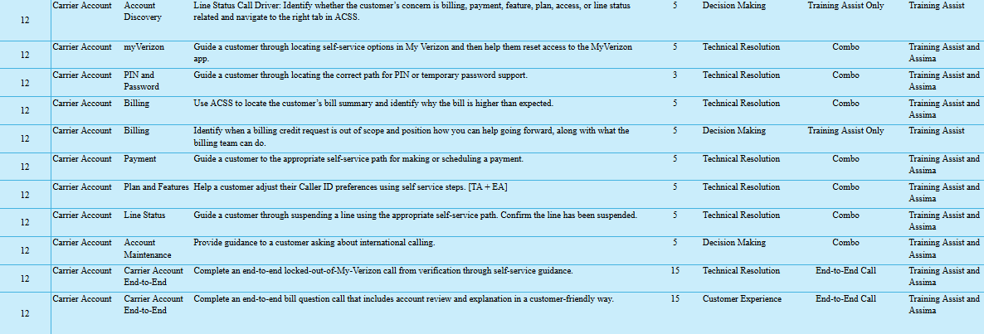

Learning Block 13: Call Flow Stage 2- Solve & Test- Insurance & Warranty Claims

  - Purpose of the Learning Block

The Insurance and Warranty Claims learning block introduces Experts to device concerns that may require Same Unit Repair (SUR), Certified Like-New Replacement (CLNR), warranty support, or an Asurion Claims path within the Resolve and Test stage of the call flow. By the end of the block, Experts should be able to clarify the customer’s concern, distinguish warranty repair from insurance support, complete required troubleshooting and eligibility checks, and use Expert Assist, Helix, ACSS, and approved workflows to determine the correct next step. Experts will practice taking a repair-first approach, offering SUR when eligible, avoiding premature replacement conversations or unnecessary transfers, and clearly explaining applicable fees, appointments, shipping, return requirements, documentation, and customer expectations with empathy and confidence.

  - Learning Objectives

By the end of this block, Experts should be able to:
- Classify customer concerns as physical damage, liquid damage, device malfunction, warranty support, coverage questions, or insurance claims based on the customer’s description and available account information.
- Ask targeted questions to identify the device symptoms, damage history, liquid exposure, timing, troubleshooting already completed, and customer expectations before selecting a resolution path.
- Demonstrate use of Expert Assist, Helix, ACSS, and approved workflows to confirm required troubleshooting, determine eligibility, and identify the tool-directed next action without overriding system results.
- Determine whether the supported path is continued troubleshooting, Same Unit Repair, Certified Like-New Replacement, an Asurion Claims process, or another approved support path.
- Explain eligibility decisions, fees, appointments, shipping, return requirements, device setup considerations, and next steps in clear, customer-friendly language.
- Respond to customer frustration or concern with specific empathy, credible assurance, and clear ownership without promising an unsupported repair or replacement outcome.
- Document the customer’s symptoms, troubleshooting steps, eligibility outcome, applicable reason codes, selected resolution path, customer agreement, and next steps accurately.

  - Key Questions Answered

The learning block should help Experts answer the following questions:

Protection and Warranty Foundations
- What types of customer concerns belong in an Asurion Claims, Same Unit Repair, or Certified Like-New Replacement path?
- What does Verizon Mobile Protect generally provide?
- How does insurance-claim support differ from warranty repair or replacement support?
- What information can Experts explain about coverage, eligibility, fees, and next steps?

Discovery and Damage Identification
- How do Experts clarify whether the concern involves physical damage, liquid damage, device malfunction, or another issue?
- What probing questions should Experts ask before selecting a repair, replacement, or claims path?
- How should Experts clarify vague or imprecise customer descriptions of device damage or performance?

Troubleshooting and Eligibility
- What troubleshooting must be completed before warranty fulfillment is considered?
- How do Experts confirm that the issue remains unresolved after supported troubleshooting?
- How do Experts use ACSS, Expert Assist, Helix, and approved workflows to validate eligibility and determine the next step?

Repair, Replacement, and Claims Decisions
- When should Experts offer Same Unit Repair first?
- When does Certified Like-New Replacement apply?
- When must the customer use a self-service or Asurion Claims path instead of a warranty repair or replacement process?
- How should Experts position repair when the customer initially requests a replacement?

Customer Expectations and Next Steps
- How do Experts explain repair appointments and what the customer should expect?
- How do Experts explain applicable CLNR costs, shipping, and return-device requirements?
- How do Experts communicate fees, timelines, customer responsibilities, and next steps without overpromising?

Documentation and Process Accuracy
- What information must Experts document about the concern, troubleshooting, eligibility, selected path, and customer expectations?
- How does accurate documentation help prevent customer confusion, compliance errors, and No Trouble Found outcomes?

  - Core Capabilities

Upon successful completion of this learning block, Experts are prepared to:

- Evaluate customer concerns involving device damage, malfunction, warranty, repair, replacement, and claims to determine the appropriate resolution path.
- Use approved tools, workflows, and eligibility information to validate repair, replacement, warranty, and claims decisions before communicating customer guidance.
- Apply repair-first decision making by recommending the appropriate support option based on eligibility, customer circumstances, and approved business processes.
- Guide customers through warranty, repair, replacement, and claims processes by communicating expectations, timelines, costs, and next steps with confidence and empathy.
- Determine when customer concerns require warranty support, insurance claims, repair, replacement, escalation, or another approved support path while maintaining compliance throughout the interaction.
- Build the decision-making and customer guidance capabilities required to confidently support warranty, repair, replacement, and claims-related customer interactions in production.

  - Assessment Methods
- Knowledge Check
- Simulation
  - Training Assist
  - Assima
    - Expert Workspace
    - TRG
    - ACSS

  - Minimum Performance Expectations

Experts must demonstrate the ability to:

- Successfully complete all 8 required Insurance & Warranty Claims simulations, including successful re-demonstration of any skill requiring coaching before progressing.
- Ask purposeful discovery questions and correctly determine whether the customer needs warranty, coverage, repair, or insurance-claim guidance in 100% of evaluated discovery scenarios.
- Use the appropriate approved tool to locate coverage information for the correct customer line in 100% of evaluated coverage-verification scenarios.
- Explain available coverage and support options in clear, customer-friendly language without promising claim approval, eligibility, or a specific outcome in 100% of evaluated coverage conversations.
- Complete required troubleshooting before determining that a concern is warranty-related, confirm Same Unit Repair eligibility, and position SUR as the first supported option in 100% of applicable warranty scenarios.
- When a customer declines an eligible SUR option, explain the applicable fee and next steps accurately before processing a CLNR through the approved workflow.
- Correctly identify when device damage requires an insurance-claim path and guide the customer to the approved phoneclaim.com self-service process in 100% of applicable claims scenarios.
- Set accurate expectations about deductibles, fees, and charges without promising claim approval, replacement eligibility, or a specific replacement type in 100% of evaluated claims-education scenarios.
- Direct customers seeking the status of an existing claim to the approved phoneclaim.com self-service path in 1 of 1 evaluated scope-decision scenario.
- Successfully complete the end-to-end warranty simulation with a score of at least 85% by completing troubleshooting, confirming the absence or presence of damage, checking SUR eligibility, explaining the available path, and completing scheduling or the supported next step.
- Complete all evaluated activities with zero critical warranty, claims, or compliance errors, including:
  - Skipping required troubleshooting.
  - Reviewing coverage for the wrong customer line.
  - Misrepresenting coverage or eligibility.
  - Promising claim approval or a specific replacement outcome.
  - Bypassing an available SUR path.
  - Processing an unsupported CLNR.
  - Directing the customer to the wrong warranty or claims path.

  - Courses and Resources (~1.5 hours)

Course | Modality | Estimated Duration | Core Capabilities # | Simulations | High-Level Description
Introduction to Repair and Replacement | Video | 10 min | 1 | 1 | Frame physical device issues, warranty repair, claims routing, and repair-first thinking before Experts move into detailed decisioning. It should reinforce why Experts probe, troubleshoot, validate eligibility, use approved tools, and document accurately instead of jumping straight to replacement.
Insurance Claims | CBT | 25 min | 1 | 3 | Introduce Verizon Mobile Protect and clarify how Experts support coverage, enrollment, eligibility, fee, limit, and claim-adjacent questions at a high level. It should also show when the customer must be routed to Asurion Claims and how to avoid unsupported claims guidance or overpromising.
Device Repair, and Warranty (CLNR) | CBT | 30min | 1-7 | 7 | Combine physical issue identification, warranty handling, Same Unit Repair, and CLNR into one connected repair-and-replacement experience. Experts should learn how to distinguish damage from malfunction, probe for symptoms and prior troubleshooting, validate eligibility in approved tools, lead with SUR when eligible, explain CLNR when appropriate, and document reason codes, expectations, and customer agreement.  This CBT will end with a formative knowledge check.

  - Simulation Strategy (~1 hour)

Experts should be able to identify whether the customer concern belongs in claims, warranty, SUR, or CLNR; ask purposeful probing questions; use approved resources to validate eligibility; and confidently guide the customer to the right next step while maintaining trust throughout the interaction.

They will move into progressive simulations that develop decisioning capability. Simulations should gradually increase in ambiguity to develop the following in Experts:
- Listening to customer concerns and identifying the true intent
- Probing for physical damage, liquid damage, symptoms, and previous troubleshooting
- Using Expert Assist, Helix, ACSS, and approved workflows to validate decisions
- Leading with SUR when eligible and positioning repair benefits clearly
- Determining when CLNR or claims routing is appropriate
- Setting clear expectations around fees, appointments, shipping, return devices, and next steps
- Documenting accurately and avoiding unsupported overrides or assumptions
- Communicating with empathy and assurance when the customer is frustrated or worried

Total Simulations: 8

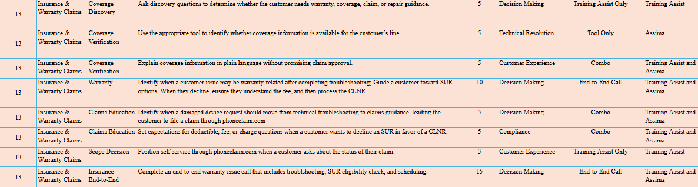

Learning Block 14: Call Flow Stage 4- Sales in Action

  - Purpose of the Learning Block

The Sales in Action learning block introduces Experts to the offering VHDP part of the call flow and prepares them to continue the customer experience after the original concern has been resolved or an approved next step has been established. By the end of the block, Experts should be able to determine whether an offer is appropriate, transition naturally into the Smart Offer, use approved resources to present relevant benefits and price, address customer questions or concerns, ask for the sale, and complete the approved enrollment process accurately and compliantly. Experts will practice adapting their language to the customer, supporting informed choice, respecting a decline, and continuing to resolve the original need rather than forcing a sales transition when an offer is not appropriate.

  - Learning Objectives

By the end of this block, Experts should be able to:
- Determine whether the customer’s original concern is resolved, partially resolved, or unresolved and select the appropriate next action: continue service, establish next steps, or proceed to an offer.
- Deliver a customer-centered transition that connects the troubleshooting outcome and the customer’s stated needs to the Smart Offer without sounding scripted or abrupt.
- Explain the purpose, sequence, and customer value of each component of the Smart Offer.
- Use GPS and ExWo to locate and verify current product details, pricing, process steps, and required language before presenting the offer.
- Translate approved product information into concise, relevant benefits and communicate the applicable price clearly and accurately.
- Identify customer questions, hesitation, or objections at any point in the offer and respond using approved, relevant information.
- Ask directly for the sale, respond appropriately to the customer’s acceptance or decline, and complete the approved link or SMS workflow.
- Identify sales-compliance risks in realistic customer interactions and correct the language, decision, or behavior using approved guidance.

  - Key Questions Answered

The learning block should help Experts answer the following questions:

Buying Decision and Offer Timing
- How do Experts determine what should happen after troubleshooting?
- What should Experts do when the customer’s original concern is not fully resolved?
- When is it appropriate to continue into a sales conversation rather than continue resolving the original need?

Smart Offer and Transition
- What is the Smart Offer, and how do its components work together?
- How do Experts transition naturally from solving the customer’s concern to presenting an offer without sounding scripted or abrupt?

Tools, Benefits, and Price
- How do GPS and ExWo support an accurate, customer-specific offer?
- How do Experts select and explain the most relevant benefits based on what the customer shared?
- How do Experts communicate price clearly and accurately?

Customer Concerns
- How do Experts recognize customer questions, hesitation, or objections at any point in the offer?
- How do Experts respond to offer concerns using approved, relevant information?

Closing and Enrollment
- How do Experts directly ask for the sale?
- How do Experts complete the approved link or SMS process after the customer accepts?

Sales Compliance
- How do Experts recognize and correct sales-compliance issues?
- How do Experts maintain informed customer choice and avoid pressure, misleading statements, or unsupported promises throughout the offer?

  - Core Capabilities

Upon successful completion of this learning block, Experts are prepared to:
- Integrate sales naturally into the customer interaction by transitioning from problem resolution to a customer-specific Smart Offer when appropriate.
- Present relevant product recommendations by connecting customer needs, discovery information, and approved product benefits to create value for the customer.
- Use approved sales tools and resources to verify eligibility, pricing, product information, required disclosures, and process requirements before presenting an offer.
- Guide customers through the complete Smart Offer process by addressing questions, resolving concerns, obtaining consent, and completing required enrollment activities while maintaining compliance.
- Balance customer experience, business objectives, and compliance requirements by recognizing when to continue selling, when to resolve additional concerns, and when not to pursue a sales opportunity.
- Build the consultative selling capabilities required to consistently execute compliant, customer-centered sales conversations in production.

  - Assessment Methods
- Knowledge Check
- Simulation
  - Training Assist
  - Assima
    - Expert Workspace

  - Minimum Performance Expectations

Experts must demonstrate the ability to:

- Successfully complete all 10 required Sales in Action simulations, including successful re-demonstration of any skill requiring coaching before progressing.
- Transition from confirmed resolution into the approved Smart Offer Transition Statement in 1 of 1 evaluated transition scenario without sounding abrupt or disconnected from the customer’s experience.
- Deliver 100% of the required Core Benefits as written in both required Smart Offer scenarios, including one scenario that incorporates natural conversational language without changing the approved meaning.
- Complete the approved Smart Offer flow after account assessment and connect the recommendation to information relevant to the customer in 1 of 1 evaluated recommendation scenario.
- Pause the Smart Offer in 1 of 1 evaluated missing-information scenario when required eligibility or account information is unavailable and use the approved process before continuing.
- Respond to the customer’s first objection in 1 of 1 evaluated objection scenario by acknowledging the concern with empathy and providing one approved, relevant value statement.
- Recognize and respect a clear customer decline in 1 of 1 evaluated decline scenario by ending the offer conversation and returning to a professional, service-focused close without additional pressure.
- Obtain clear, customer consent in 1 of 1 evaluated consent scenario after completing a compliant offer conversation.
- Complete the approved enrollment workflow in 1 of 1 evaluated enrollment scenario only after consent is received, with zero enrollment actions completed before consent.
- Successfully complete the end-to-end Sales in Action simulation with a score of at least 85% by completing account assessment, making the appropriate offer decision, delivering the Smart Offer, responding to the customer’s decision, and closing the interaction professionally.
- Complete all evaluated activities with zero critical sales-compliance errors, including:
  - Transitioning to an offer before the customer’s service concern is resolved or has an approved next step.
  - Omitting or changing required Core Benefits.
  - Continuing the offer without required eligibility or account information.
  - Providing unsupported product, pricing, or coverage information.
  - Continuing to sell after a clear customer decline.
  - Applying excessive pressure or unsupported rebuttals.
  - Beginning enrollment without customer consent.
  - Completing an unauthorized or inaccurate enrollment action.

  - Courses and Resources (~1.5 hours)

Course | Modality | Estimated Duration | Core Capabilities # | Simulations | High-Level Description
Buying Decision | Video | 10 min | 1 | 1 | This video should help Experts decide whether the customer is ready for a Smart Offer after troubleshooting. It should cover resolved, partially resolved, and unresolved service situations, including when to continue solving, set next steps, escalate, or avoid making the sale feel more important than the original need.
Smart Offer Overview | Video | 10 min | 3, 4 | N/A- overview | Introduce the Smart Offer flow as a flexible conversation structure rather than a script. It should show how transition, relevant benefits and price, concern resolution, and close work together, while reinforcing GPS and ExWo as sources of truth and compliance as part of the entire offer.
Ascend_Soluto_VZW_Smart Offer Part 1/2 - Intro to the Smart Offer | CBT | 15 min | 2X | 2X | This CBT introduces the Smart Offer in Sales assist and helps Experts learn what each component of Smart Offer is and how they sound.
Ascend_Soluto_VZW_Smart Offer Part 2/2 - Conversational Language and Completing a Great Offer | CBT | 20 min | 4,6,7 | 5,2,1 | This CBT introduces and incorporates conversational language to Smart Offer and shows how each of the previously learned components can now be enhanced with conversational language. It then has a section on Resolving Concern/rebuttals and completing enrollment.
Sales Compliance Refresher | CBT | 15 min | 4, 8 | 3 | Reinforce compliant selling behaviors during Smart Offer execution. Experts should identify common compliance risks in realistic conversations and correct them using approved guidance, accurate information, customer consent, and non-pressure language.

  - Simulation Strategy (~45 minutes)

Experts should practice using the Smart Offer as a natural continuation of service after the original customer need has been resolved or taken as far as possible.

Simulations should build from transition, offer, concern resolution, and close into full sales conversations that require compliant language, customer-specific value, and respect for the customer’s decision.

Total Simulations: 10

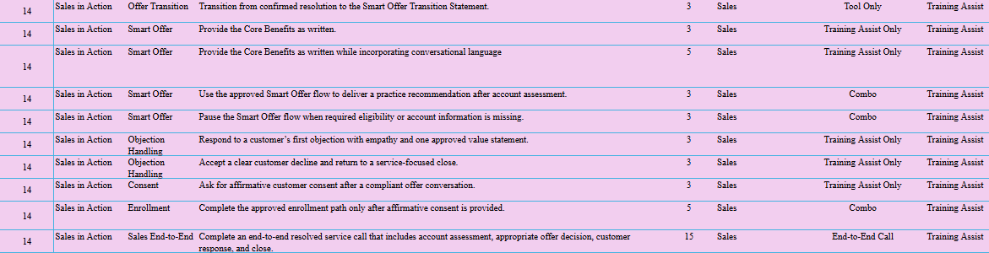

  - Instructional Design Guidance

For every course within this learning block, instructional designers should define:
- Content: What information is delivered.
- Modality: How the learning is delivered (ILT, CBT, simulation, activity, etc.).
- Practice: How Experts apply the knowledge or skill.
- Performance Check: How proficiency is demonstrated.
- Minimum Readiness Criteria: The observable behaviors or outcomes required before progressing to the next learning block.

Learning Block 15: Call Flow Stage 5- Confirm, Recap, Close
  - Purpose of the Learning Block

The Call Flow—Closing learning block introduces Experts to the Confirm, Recap, and Close stage of the Verizon Tech Coach call flow. By the end of the block, Experts should be able to confirm that the customer’s concern has been resolved or taken to the furthest supported point, summarize the concern, actions, and outcome, communicate any remaining next steps, complete accurate documentation, and deliver the approved Verizon closing language. Experts will practice closing as the final step of the resolution process—not as a stand-alone script—while maintaining confidence, clarity, and ownership through the end of the interaction.
  - Learning Objectives

By the end of this block, Experts should be able to:
- Test or validate the customer’s original concern and obtain customer confirmation of the outcome before closing the interaction.
- Determine whether the concern is resolved, partially resolved, or unresolved and select the appropriate closing, next-step, transfer, or escalation path.
- Recap the customer’s concern, actions completed, and outcome using clear, customer-friendly language.
- Communicate any remaining actions, customer responsibilities, expected timeframes, and next steps while avoiding unnecessary customer effort.
- Document the customer’s concern, actions taken, outcome, and next steps accurately before closing or transferring the interaction.
- Transition appropriately from a sales conversation based on whether the customer accepts, declines, or does not receive an offer, then return to the appropriate service-focused close.
- Deliver the approved Verizon closing language only after confirming that all customer concerns, documentation, and next steps have been addressed.

  - Key Questions Answered

The learning block should help Experts answer the following questions:

Resolution Confirmation
- How do Experts confirm that the customer’s issue has been resolved?
- What should Experts communicate when the issue is only partially resolved or has been taken to the furthest supported point?
Recap and Next Steps
- How do Experts summarize the customer’s concern, actions completed, and outcome without sounding robotic?
- How do Experts clearly explain remaining customer actions, expected timeframes, and next steps?

Transfer, Escalation, and Unresolved Concerns
- How do Experts close or hand off an interaction when a transfer or escalation is required?
- How do Experts set expectations when the concern remains unresolved or requires another support path?

Closing After a Sales Conversation
- How do Experts close the interaction after presenting a sales offer?
- How should the close differ when the customer accepts, declines, or completes an enrollment?

Documentation
- What information must Experts document before ending or transferring the interaction?
- How do Experts confirm that the documentation accurately reflects the concern, actions, outcome, and next steps?

Approved Closing Language
- What approved Verizon closing language should Experts use?
- Which closing components are required, and which language may be delivered naturally?
- What should Experts avoid saying during the close?

  - Core Capabilities

Upon successful completion of this learning block, Experts are prepared to:
- Conclude customer interactions by confirming outcomes, summarizing completed actions, communicating next steps, and ensuring the customer understands the resolution.
- Determine the appropriate closing approach based on the customer’s outcome, including resolved, partially resolved, transferred, escalated, post-sales, or follow-up scenarios.
- Validate customer outcomes using approved tools, workflows, and customer confirmation before ending the interaction.
- Complete customer interactions by accurately documenting the issue, actions taken, outcome, and remaining next steps while maintaining compliance and protecting customer information.
- Deliver professional, customer-centered closings that reinforce ownership, minimize unnecessary customer effort, and create confidence in the resolution provided.
- Build the closing and documentation capabilities required to consistently conclude customer interactions in production.

  - Assessment Methods

- Simulation
  - Training Assist
  - Assima
    - Expert Workspace
    - Expert Assist

  - Minimum Performance Expectations

Experts must demonstrate the ability to:
- Successfully complete all 5 required Call Flow—Closing simulations, including re-demonstration of any skill that requires coaching.
- Test the customer’s original concern in 100% of applicable scenarios before confirming resolution. For the email scenario, the Expert must guide the customer through sending an email and confirm that it sends successfully.
- Deliver a complete three-part close that includes:
  - A recap of the concern, resolution, and completed plan enrollment.
  - Any remaining customer actions or next steps.
  - A customer satisfaction or understanding check before the final closing.
- Close a partially resolved interaction by clearly explaining:
  - What was completed.
  - What remains unconfirmed.
  - When and how the customer should test the result.
  - What the customer should do if the expected result does not occur.
- Close an escalation with ownership by explaining why additional support is required, what will happen next, and what the customer should expect during the handoff.
- Transition appropriately out of a sales conversation by delivering the Smart Offer, using only the permitted rebuttals, respecting a clear decline, and returning to a professional, service-focused close without additional pressure.
- Communicate the outcome and next steps in clear, customer-friendly language without sounding scripted, making unsupported promises, or creating unnecessary customer effort.
- Confirm that the customer understands the resolution, remaining actions, or escalation path before ending the interaction.
- Achieve at least 85% across the evaluated closing simulations and complete all activities with zero critical closing errors, including:
  - Ending the interaction without testing the original concern.
  - Describing a partially resolved concern as fully resolved.
  - Omitting required next steps or expectations.
  - Ending an escalation without explaining the handoff.
  - Continuing to sell after a clear customer decline.
  - Closing before all identified customer concerns have been addressed or taken to the furthest supported point.

  - Courses and Resources (~30 minutes)

Course | Modality | Estimated Duration | Core Capabilities # | Simulations | High-Level Description
The Closing Framework | CBT | 20 min | 1-8 | 5 | This CBT should teach the core close: test and confirm the outcome, summarize what was completed, deliver the appropriate resolution statement, and use approved Verizon closing language. It should also cover how to close when the issue is partially resolved, transferred, escalated, post-offer, or requires follow-up, including use of the Expert Workspace session summary.

  - Simulation Strategy (~40 minutes)

Experts should practice closing as the final part of the resolution loop: confirm the outcome, summarize what was completed, communicate next steps, document accurately, and use approved closing language.

Simulations should progress from resolution confirmation to three-part close practice and then a full closing sequence with the Expert Workspace session summary.

Total Strategies: 5
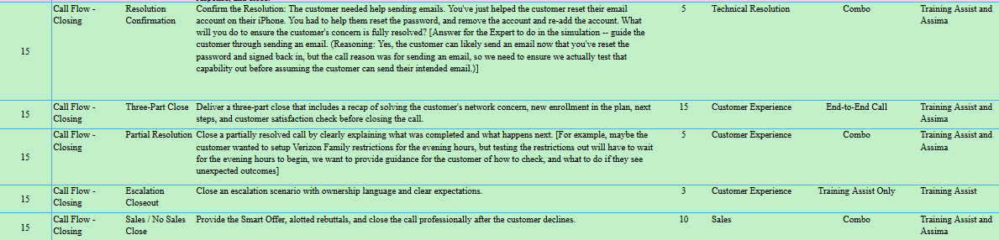

  - Instructional Design Guidance

For every course within this learning block, instructional designers should define:
- Content: What information is delivered.
- Modality: How the learning is delivered (ILT, CBT, simulation, activity, etc.).
- Practice: How Experts apply the knowledge or skill.
- Performance Check: How proficiency is demonstrated.
- Minimum Readiness Criteria: The observable behaviors or outcomes required before progressing to the next learning block.

Learning Block 16: Expert Readiness- Training Closing

  - Purpose of the Learning Block

The Expert Readiness learning block prepares Experts to transition into live customer interactions by integrating the technical, operational, decision-making, and communication skills developed throughout Ascend. During this block, Experts will learn how to view and track their schedules in Aspect, review the performance metrics against which they will be measured in operations, and complete all required Verizon and client-specific training. Experts will also complete seven final simulations in which they apply the full call flow from greeting and verification through discovery, resolution, documentation, and close. By the end of the block, Experts should be able to adapt to changing customer needs, use approved tools and resources, follow required operational procedures, and demonstrate the judgment, confidence, and end-to-end performance needed to transition to production.

  - Learning Objectives

During this learning block, Experts will:
- Navigate Aspect to view their assigned schedule and submit schedule-related requests using the approved process.
- Review the performance metrics used in operations and explain what aspect of Expert performance each metric measures, without being required to recall specific performance goals.
- Register their Verizon credentials with their assigned YubiKey and use it to access required Verizon tools.
- Identify the approved support process for a lost or unavailable YubiKey, including contacting their Coach for assistance.
- Complete all assigned Verizon-required and client-specific training and confirm that each completion is recorded.
- Apply the complete Verizon Tech Coach call flow in seven final simulations, from greeting and verification through discovery, resolution, documentation, and close.
- Use approved tools, resources, and operational procedures to respond to changing customer needs and make supported decisions during the final simulations.
- Demonstrate integrated technical, communication, compliance, documentation, and decision-making skills under realistic call conditions.

  - Key Questions Answered

The learning block should help Experts answer the following questions:

Aspect and Schedule Management
- How do Experts view and track their assigned schedule in Aspect?
- How do Experts submit schedule-related requests using the approved process?
- What should Experts do when schedule information is incorrect, unavailable, or does not match expectations?

Performance Metrics
- What performance metrics will be used to evaluate Experts in operations?
- What aspect of Expert performance does each metric measure?
- How can Experts use metric information, feedback, and coaching to understand and improve their performance?
- Where can Experts locate their performance information once they transition to operations?

Verizon-Required Training
- Which Verizon-required and client-specific courses must Experts complete before transitioning from training?
- How do Experts access and complete their assigned courses?

Final Simulations and Call Flow Integration
- What skills must Experts demonstrate across the seven final simulations?
- How do Experts apply the complete call flow from greeting and verification through discovery, resolution, documentation, and close?
- How do Experts select and use approved tools and resources during an end-to-end customer interaction?
- How do Experts adapt when customer needs, tool results, or the expected support path changes?
- How do Experts demonstrate technical accuracy, customer communication, compliance, documentation, and sound decision-making within the same interaction?

  - Core Capabilities

Upon successful completion of this learning block, Experts are prepared to:

- Manage complete customer interactions by integrating the communication, troubleshooting, tool usage, decision making, documentation, and sales capabilities developed throughout Launchpad.
- Adapt customer interactions based on changing customer needs, operational requirements, and business processes while maintaining ownership and customer confidence.
- Apply professional judgment to determine the appropriate support path, including troubleshooting, escalation, transfer, documentation, and sales opportunities.
- Use approved tools, resources, operational procedures, and scheduling systems to perform successfully within the production environment.
- Demonstrate production readiness by consistently applying the customer interaction model, operational processes, and business expectations across realistic customer scenarios.
- Transition confidently from Launchpad into live production by demonstrating the knowledge, skills, behaviors, and judgment expected of a Verizon Tech Coach Expert.

  - Assessment Methods
- Simulation
  - Training Assist
  - Assima
    - Expert Workspace
    - Guided Flow
    - ACSS/TRG
    - Expert Assist

  - Minimum Performance Expectations

Experts must demonstrate the ability to:
- Successfully complete all 7 required Production Readiness simulations, including successful re-demonstration of any skill requiring coaching before progressing.
- Correctly identify, prioritize, and address both customer needs in 2 of 2 multi-need simulations involving:
  - Activation and content transfer.
  - Network and billing concerns.
- Correctly adjust the support path in 3 of 3 evaluated path-change scenarios by:
  - Recognizing when an app concern indicates a broader device-performance issue.
  - Continuing discovery and selecting another supported troubleshooting step when the first action fails.
  - Pivoting to the appropriate activation path when the initial process does not work.
- Successfully de-escalate the customer in 1 of 1 evaluated de-escalation scenario by acknowledging previous effort, avoiding unnecessary repetition, maintaining ownership, explaining the next action, and continuing support when the first troubleshooting step fails.
- Use the appropriate Guided Flow, TRG, ACSS, Expert Assist, and other approved resources in 100% of applicable final simulations without skipping required prompts, guessing, or relying on unsupported workarounds.
- Successfully complete all 3 Readiness Gate simulations with a score of at least 85% on each, without Trainer guidance, corrective hints, or intervention.
- Successfully demonstrate the complete applicable call flow in 3 of 3 Readiness Gate simulations by:
  - Delivering the approved greeting.
  - Completing verification.
  - Identifying all customer needs.
  - Conducting discovery and account assessment.
  - Selecting and using the appropriate tools and workflows.
  - Completing the supported troubleshooting or resolution path.
  - Adjusting the path when customer or tool results require it.
  - Testing and confirming the outcome.
  - Completing the Smart Offer when appropriate.
  - Documenting the interaction accurately.
  - Providing a clear recap, next steps, and professional close.
- Confirm the correct device, line, and activation need in 3 of 3 activation-related simulations before beginning activation steps.
- Successfully complete the approved activation path and validate activation results in 3 of 3 activation-related simulations, including confirming applicable calling, texting, and data functionality.
- Guide the customer through an appropriate content-transfer path in 1 of 1 evaluated content-transfer scenario, protect customer credentials, set accurate expectations, and confirm the transfer outcome or remaining next step.
- Complete the required Network and Connectivity Guided Flow and TRG steps in sequence in 1 of 1 No Network Readiness Gate simulation, test the original concern, and confirm that service is restored before moving forward.
- Complete the Smart Offer in 1 of 1 required sales scenario only after the service concern is resolved or has an approved next step, obtain customer consent, and complete the approved sales process.
- Test the customer’s original concern in 100% of final simulations where testing applies and clearly communicate the confirmed resolution or supported next step before closing.
- Accurately document the customer’s concern, relevant information, actions completed, outcome, and next steps in 3 of 3 Readiness Gate simulations before completing the interaction.
- Complete all 7 final simulations with zero critical errors, including:
  - Bypassing verification or exposing protected customer information.
  - Selecting the wrong account, line, device, or MDN.
  - Skipping required Guided Flow, TRG, tool, or troubleshooting steps.
  - Continuing down an unsupported path after the customer’s need changes.
  - Declaring resolution without testing the original concern.
  - Leaving an identified customer need unaddressed without explaining the next step.
  - Transferring or escalating without an approved reason.
  - Submitting inaccurate or incomplete documentation.
  - Presenting a sales offer before the service concern is addressed.
  - Enrolling a customer without consent.

Courses and Resources (~2 hours)
Course | Modality | Estimated Duration | Core Capabilities # | Simulations | High-Level Description
Using Aspect and Reporting Downtime Procedures | CBT | 15 min | 1 | N/A | Introduce Aspect as the tool Experts use to monitor schedules and understand alerts during the workday. It should explain how Aspect fits into day-to-day processes and what Experts should do when they need to report downtime.
Hub Metrics | CBT | 10 min | 2 | N/A | Review metrics and what is being measured including CRT, ERP, NSP100. It will not go over the goals for each metric.
Verizon Yubikey Registration | CBT | 10 min |  | N/A | Introduces through the steps of registering their Verizon Yubikey with their Verizon credentials.
Verizon Required Courses | CBT | 1:45 | 3 | N/A | This required course bundle should be completed in the Verizon platform before Experts take real calls. It includes Verizon-required compliance and sales content such as CPNI Annual Training, TCPA, state privacy laws, Sales Agent Standards of Conduct, and Selling with Integrity, with additional required courses continuing in Immersion as applicable.  - VZ Learn- CPNI Annual Training- VZ154364  - VZ Learn- Fundamental Telephone Consumer Protection Act- VZ151865  - VZ Learn- tate Comprehensive Privacy Laws- Consumer- VZ135918  - VZ Learn- Verizon Sales Agent Standards of Conduct- 2025- VZ154830  - VZ Learn- Selling with Integrity- VZ156093
Note: There are additional VZW required courses to be taken in Immersion.
  - Simulation Strategy (~1 hour 45 minutes)
After completing the final required courses and operational content, Experts should move into capstone simulation practice that integrates the capabilities developed throughout Launchpad. Simulations should reflect realistic customer interactions with limited initial information and should be timed like live calls, with coaching, scoring, and debrief handled separately.
The simulations should confirm production readiness by assessing customer ownership, diagnostic thinking, communication, tool use, decision making, sales integration when appropriate, transfer or escalation judgment, documentation, and professional confidence before moving into live customer interactions.
Total Simulations- 7

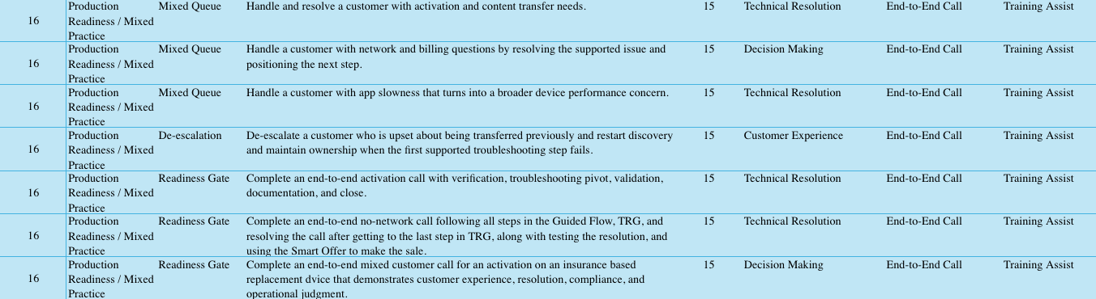

  - Instructional Design Guidance
For every course within this learning block, instructional designers should define:
- Content: What information is delivered.
- Modality: How the learning is delivered (ILT, CBT, simulation, activity, etc.).
- Practice: How Experts apply the knowledge or skill.
- Performance Check: How proficiency is demonstrated.
- Minimum Readiness Criteria: The observable behaviors or outcomes required before progressing to the next learning block.

Additional Activities
  - Call Listening
These should align with the ASCEND User Manual. Trainers should use the Expert Dashboard to determine the appropriate timing for each session based on learner progress. Each Call listening should be 45 minutes max.
Below are the recommended call types for each listening session:
- Client Tools: Trainer selects a call that demonstrates the use of both Asurion and client tools (a shorter call is preferred).
- Troubleshooting: Trainer selects a call focused on troubleshooting a customer issue.
- Networking: Trainer selects a call involving a networking-related issue.
- Activations: Trainer selects multiple calls where they view successful activations and activations where there were errors.
- Carrier Account: Trainer selects a call where the Expert uses My Verizon to resolve the customer's issue.
- Insurance and Warranty Claims: Trainer selects a call that requires either an insurance claim or a warranty claim.

  - Side-by-Sides
At the beginning of days 3, 5, and 7, the trainer should partner with Operations to pull Experts out to do live side-by-sides for no more than 1:30. Once finished, the Experts will return to the classroom and debrief what they observed for 15 minutes before jumping back into their work.

  - Innovation Lab Activities
After Experts have completed Ascend Learning Blocks 7–9, the trainer will facilitate topic-specific call listening followed by a corresponding Innovation Lab activity focused on troubleshooting, device basics, and hardware versus software at the beginning of the day. After Experts complete Learning Block 10, the same approach will be used for networking.
The Innovation Lab team will design these hands-on activities to reinforce completed learning through real-world application and problem-solving.

LaunchPad Outcome

At the end of the Launchpad training experience, Experts will have completed 16 Learning Blocks designed and sequenced to prepare them for operational readiness. This readiness is demonstrated through the successful completion of 182 progressive simulations built across every supported call type, followed by 7 Production Readiness simulations in Learning Block 16. The final 3 of those 7 are Readiness Gate simulations, each requiring a score of 85% or higher, completed without trainer guidance or intervention, covering the full call flow from greeting through documentation and close.
At the successful completion of this learning experience, Experts will be prepared to perform at the following KPI levels during the Immersion phase:
Metric | Minimum (Standard Graduation) | Target (Accelerated Graduation)
Serve (ERP) | 86 | 88
Solve (Resolution Rate) | 84% | 86%
Sell (NSP100) | 2.0 | 3.0
Productivity (CRT) | 1,750s | 1,650s
Experts graduate by meeting all Minimum Performance Requirements at 8 weeks of tenure (approximately 250 live calls), or by meeting all Target Performance Expectations over a rolling 100-call period within the first 8 weeks.

